Name: __________________ Table #: _____ Period: _____ Date: ______
7.4A Classifying Real Numbers_Classwork
Objective: define and identify real numbers; approximate square roots; compare real numbers. CC.SS.8.NS.1_MP1
HW: 7.1 Practice Review/ 7.2 Practice Review (handout)
Video: https://www.youtube.com/watch?v=0OwvN-957aE
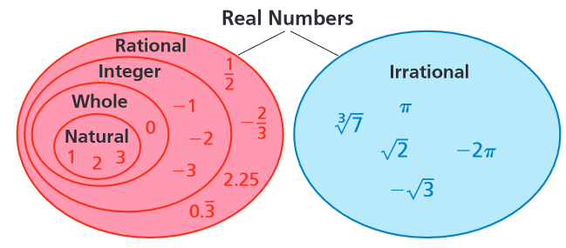
Words | Definitions and Examples
Real  Numbers | All _____________ & _______________ #’s
Rational #’s  *Terminating Decimals  *Repeating Decimals | All  _________________ #’s Ex’s:  _________________ #’s Ex’s:  _________________ Ex’s:  _________________ Ex’s:  SQUARE ROOTS OF __________ SQUARES  Ex’s:  CUBE ROOTS OF ___________ CUBES  Ex’s:  DECIMALS (terminating or repeating)  Decimals that __________ (terminate) Ex’s:  Decimals that ______________________ AND ______________ in a pattern  Ex’s:
Irrational #’s | Non-____________/ Non-______________ Decimals  Ex’s:  Square roots of #’s that are NOT _________________  Ex’s:  Cube roots of #’s that are NOT ___________________  Ex’s:
Integers | Positive, negative whole numbers, and zero  Examples of Integers:  Examples of NON-Integers:
Whole Numbers
Natural Numbers

PRACTICE PROBLEMS: Mark an X for each category that applies.
 | Number | Real | Rational | Irrational | Integer | Whole | Natural
1 | -6
2 | 0.593672…
3 | 0
4 | $$\frac{}{2}$$
5 | 2.393939…
6 | $$\frac{2}{5}$$
7 | $$\sqrt[3]{100}$$
8 | √25
Video: https://www.youtube.com/watch?v=IK0OR2vg_Qc

