Name: __________________________ Table #: _______ Period: _______ Date:_________
7.4B Estimating Square Roots_Classwork
Objective: Approximate square roots (pre-req. for CCSS 8.NS.2
HW: (7.4A) p. 313 #20 – 23, 26 – 31, 43 (Solutions on p. A33)

WARM UP
- Find the side length of a square with an area of 25 cm² (7.1 NOTES)

- Find the side length of a cube with a volume of 343 in³ (7.2 NOTES)

- Find the radius of a circle with an area of 225π (7.1 NOTES)

Which number is greater? EXPLAIN. (SAME AS O.Y.O. p. 312 #8 – 10)
- 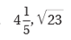 |  | - 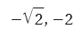

CONTINUED ON BACK $→$
SQUARE NUMBERS: 1, 4, 9, 16, 25, 36, 49, 64, 81, 100, 121, 144, 169, 196, 225, 256, 289, 324, 361, 400

WATCH TUTORIAL VIDEO, LESSON 7.4, EXAMPLE 2, THEN DO O.Y.O. p. 311 #4 – 7
EXAMPLES:
Estimate $\sqrt{23}$ to the nearest (a) integer and (b) tenth.  - $\sqrt{23}$ is between $\sqrt{16}$ and $\sqrt{25}$.  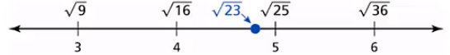  - Guess and check the estimate of the square root to the nearest tenth.  4.5² = 20.25  4.7² = 22.09  4.8² = 23.04 | Estimate $-\sqrt{67}$ to the nearest (a) integer and (b) tenth.
ESTIMATE THE SQUARE ROOT TO THE NEAREST (a) INTEGER AND (b) TENTH.

