Name: ________________________ Table #: ______ Period: _______ Date: _______
7.4B Quadrilaterals_Classwork

Objective: classify and construct qdarilaterals. CC.SS.7.G.2
HW: textbook: 7.4B pg 296 #1-23 ALL
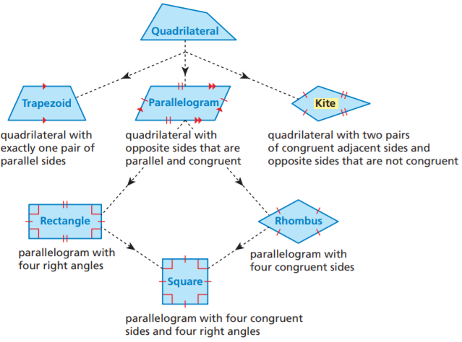

State all possible name for each figure
1.  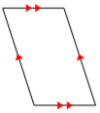 | 2.  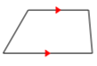 | 3.  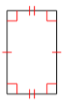 | 4.  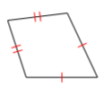
5.  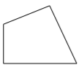 | 6.  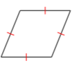 | 7.  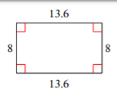 | 8.  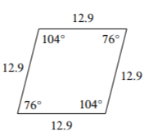
9.  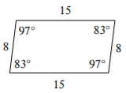 | 10.  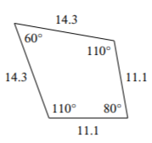 | 11.  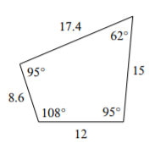 | 12.  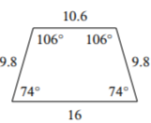
WARM-UP
1.
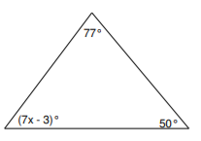

2.
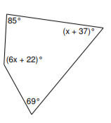

https://cdn.kutasoftware.com/Worksheets/Geo/6-Classifying%20Quadrilaterals.pdf
https://cdn.kutasoftware.com/Worksheets/PreAlg/Angle%20Sum%20of%20Triangles%20and%20Quadrilaterals.pdf

