Name ________________________________________ Table# ____ Period: ______ Date:_____________

7.4e A NOTES – Repeating Decimals

Objective: Students can convert a repeating decimal to a fraction by writing and solving equations. CCSS: 8.NS.1.
HW: (7.4e1) p. 316 #1 – 4 (Solutions on p. A33)

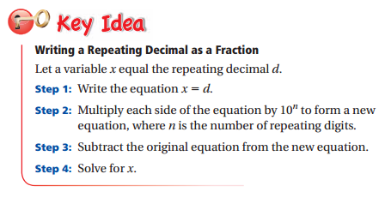 | WATCH VIDEO: 7.4e, EXAMPLE 1  Write $1.\overline{7}$ as a fraction in simplest form.  Step 1: $x=1.\overline{7}$  Step 2: $10∙x=1.\overline{7} ∙10$  $10x=17.\overline{7}$  Step 3: - $( x= 1.\overline{7)}$  9x = 16  Step 4: $\frac{9x}{9 }= \frac{16}{9}$  $x= \frac{16}{9}=1\frac{7}{9}$ so $1.\overline{7}= \frac{16}{9}=1\frac{7}{9}$

EXAMPLES
- Write $1.\overline{7}$ as a fraction in simplest form. | - Write $-2.\overline{4}$ as a mixed number.
BACK

ON YOUR OWN
1. Write $0.\overline{4}$ as a fraction in simplest form | 2. Write $-1.\overline{8}$ as a fraction in simplest form.
3. Write $2.\overline{1}$ as a mixed number | 4. Write $-3.\overline{5}$ as a fraction in simplest form

++++++++++++++++++++++++++++++++++++++++++++++++++++++++++++++++++++++++++++++++++++++++++
WARM-UP
1. Convert $2\frac{3}{5}$ to an improper fraction. | 2. Convert $\frac{17}{4}$ to a mixed number.
Mark an X for each category that applies.
 | Number | Real | Rational | Irrational | Integer | Whole | Natural
3 | 0
4 | -1.125
5 | 0.9875298752…
6 | $$\sqrt[3]{-216}$$
7 | 3.592345..
8 | $$\sqrt{80}$$

