Name ________________________________________ Table# ____ Period: ______ Date:_____________

7.5A Distance Formula_Classwork
Objective: Apply Pythagorean Theorem to find distance between 2 points in coordinate system.
HW: (7.5A) p. 322 #11 - 17 (Odd solutions on p. A34). CCSS: 8.G.8
Video: https://www.youtube.com/watch?v=We3LG8pK-LU

***START WITH WARM UP & LESSON OPENER ON BACK ***
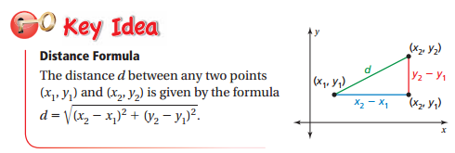
Example 2 (p. 321)
Find the distance between (1, 5) and (-4, -2)

ON YOUR OWN (p. 321). Directions: FIND THE DISTANCE BETWEEN THE TWO POINTS.
3. (0, 0), (4, 5)

4. (7, -3), (9, 6)

5. (-2, -3), (-5, 1)

Warm Up:
A surveyor holds a laser range finder 2 feet above the ground and determines that the range finder is 100 feet from a building and 110 feet from the top of the building. What is the height h of the building? Round your answer to the nearest tenth.

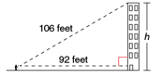

Lesson Opener:
You are playing capture the flag. You are 50 yards north and 20 yards east of your team’s base. The other team’s base is 80 yards north and 60 yards east of your base. How far are you from the other team’s base?
STEP 1: Draw the situation in a coordinate plane. Let the origin represent your team’s base.
STEP 2: Draw a right triangle with a hypotenuse that represents the distance between you and the
other team’s base. Find the length of those legs.
STEP 3: Use the Pythagorean Theorem to find the length of the hypotenuse.

CLASS SET. DO NOT WRITE ON. LEAVE FOR THE NEXT CLASS
HW: (7.5A) p. 322 #11 - 17 (Odd solutions on p. A34)

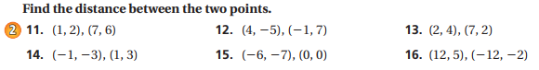
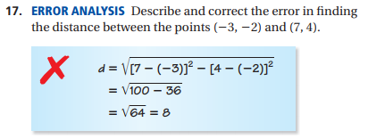
Solutions: 11) $\sqrt{52}$ 12) 13 13) $\sqrt{29}$ 14) $\sqrt{40}$ 15) $\sqrt{85}$ 16) 25 17) Student answers will vary

CLASS SET. DO NOT WRITE ON. LEAVE FOR THE NEXT CLASS
HW: (7.5A) p. 322 #11 - 17 (Odd solutions on p. A34)

Solutions: 11) $\sqrt{52}$ 12) 13 13) $\sqrt{29}$ 14) $\sqrt{40}$ 15) $\sqrt{85}$ 16) 25 17) Student answers will vary

