Name ________________________________________ Table# ____ Period: ______ Date:_____________

7.5B Converse of The Pythagorean Theorem_Classwork

Objective: Use the converse of the Pythagorean Theorem to identify right triangles. CCSS: 8.G.6
HW: (7.5B) p. 322 #5 –10, 19 – 21, 23 (Solutions on p. A34)
WARM UP
A civil engineer is mapping the overhead clearance of his family’s property on a coordinate grid. The ground is represented by the x-axis and the base of the house is at the origin. There are two big trees on the property. One tree is 8 feet from the base of the house and 13 feet tall. The other tree is 12 feet from the base of the house and is 10 feet tall. What is the distance from the base of the house to the closest treetop? Round your answer to the nearest tenth.

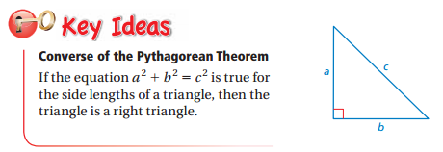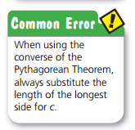
Example 1 (p. 320)
DIRECTIONS: Tell whether each triangle is a right triangle.
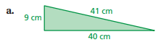 | 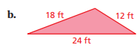
ON YOUR OWN (p. 320)
DIRECTIONS: Tell whether the triangle with the given side lengths is a right triangle.
1. 28 in., 21 in., 20 in. | 2. 1.25 mm, 1 mm, 0.75 mm

EXAMPLE 3: Tell whether a triangle with the given side lengths is a right triangle: $\sqrt{105}, 19, 16$

Example 4:
One of the sides of a right triangle has a measurement of 15 units. Which of these statements is correct? Select all that apply.

- The length of the other leg is 8 units, the length of the hypotenuse is 17.
- The length of the legs are 9 units and 12 units.
- The length of the other leg is 36, the length of the hypotenuse is 40.
- The length of the other leg is 20, the length of the hypotenuse is 25.

