Name ________________________________________ Table# ____ Period: ______ Date:_____________

7.5B NOTES – Converse of The Pythagorean Theorem

Objective: Use the converse of the Pythagorean Theorem to identify right triangles. CCSS: 8.G.6
Video: https://www.youtube.com/watch?v=NIdVnE2Ab-k
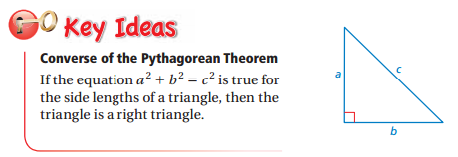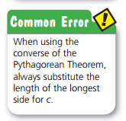

EXAMPLE 1: (p. 320)
DIRECTIONS: Tell whether each triangle is a right triangle.
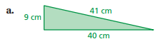 | 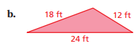

EXAMPLE 2: Tell whether a triangle with the given side lengths is a right triangle: $\sqrt{18}, 8, 9$

ON YOUR OWN (p. 320)
DIRECTIONS: Tell whether the triangle with the given side lengths is a right triangle.
- 28 in., 21 in., 20 in. | - 1.25 mm, 1 mm, 0.75 mm | - Tell whether a triangle with the given side lengths is a right triangle: $\sqrt{105}, 19, 16$

BACK
Example 4:
One of the sides of a right triangle has a measurement of 15 units. Which of these statements is correct? Select all that apply.
- The length of the other leg is 8 units, the length of the hypotenuse is 17.
- The length of the legs are 9 units and 12 units.
- The length of the other leg is 36, the length of the hypotenuse is 40.
- The length of the other leg is 20, the length of the hypotenuse is 25.

CLASSWORK: Login BIM and complete 7.5B pg 322 #5 –10, 19 – 21, 23. Show your work on this paper.
5. | 6.
7. | 8.
9. | 10.
19. | 20.
21. | 23.

