Name: _________________________ Table #: _______ Period: ______ Date: ______
8.0A NOTES – Area of Shapes
Objective: find the area of composite figures by applying the area of basic shapes.

AREA FORMULAS
Area (rectangle) = length $∙$width (A = L $∙$ W) Area (triangle) = $\frac{base∙height}{2}$ $\left(A= \frac{bh}{2}\right)$
Area (circle) = pi $∙$radius² $\left(A=πr^{2}\right)$ $Radius=\frac{diameter}{2}$ $\left(r=\frac{d}{2}\right)$

Find the area of the circles. Use 3.14 for $π$
EXAMPLE 2 (p. 333)  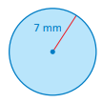 | EXAMPLE 3 (p. 333)  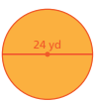

ON YOUR OWN (p. 333)
1.  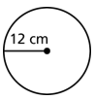 | 2.  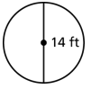 | 3.  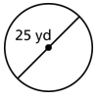 | 4.  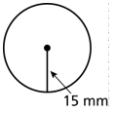

BACK

COMPOSITE SHAPES: A figure (or shape) that can be divided into more than one of the basic figures is said to be a composite figure (or shape).

Find the area of each composite shape.
EXAMPLE 1  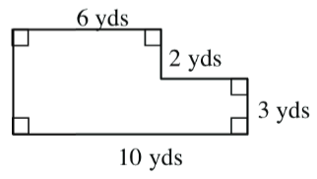  Area of Rectangle: $4∙3=12 {yd}^{2}$  Area of Rectangle: $6∙5=30{ yd}^{2}$  Total: $42 {yd}^{2}$ | EXAMPLE 2  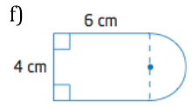  Area of Rectangle: $4∙6= 24 {cm}^{2}$  Semi-circle: $\left[\left(3.14\right){∙2}^{2}\right]÷2= 6.28 cm^{2}$  Total: $≈30.28 cm^{2}$ | EXAMPLE 3  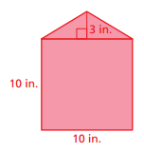  Area of Triangle: $\frac{3∙10}{2}=15 {in}^{2}$  Area of Square: $10∙10=100 {in}^{2}$  Total: $115 {in}^{2}$

Find the area of each figure.
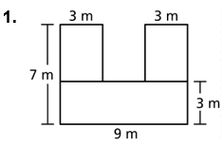

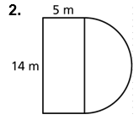

3.
