Name: ___________________________________________ Table #: ______ Period: _______ Date: _______
KLA #4 Quiz 8.1-8.2 Correction HOMEWORK
DIRECTIONS: Circle the problem numbers you missed on Quiz (8.1-8.2). (Go to “Reports”; then “Review” in BIM) Do these questions for HW. USE PI
- Find the volume of the cylinder. Round your answer to the nearest tenth.  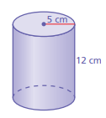 | - Find the volume of the cylinder. Round your answer to the nearest tenth.  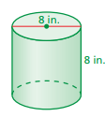
- The volume of the cylinder is 340 ft³. Find the height. Round your answer to the nearest whole number.  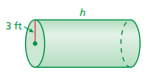 | - Find the volume of the cone. Round your answer to the nearest tenth.  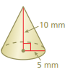
- Find the volume of the cone. Round your answer to the nearest tenth.  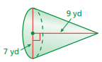 | - Find the height of the cone. Round your answer to the nearest whole number.  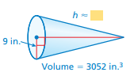
- How does the volume of a cylinder change when its diameter is quadrupled (multiplied by 4)? | - A cylindrical rain barrel with a diameter of 3.5 feet and a height of 5.5 feet is filled to a height of 2.5 feet. How many more gallons of water can the barrel hold? Round your answer to the nearest whole number.  (1 ft³ $≈$ 7.5 gal.)
- One cubic foot of sand weighs about 90 pounds. Approximate the weight of the cone-shaped pile. Round your answer to the nearest hundred pounds. (This is different from your notes where you rounded to the nearest “hundredth”)
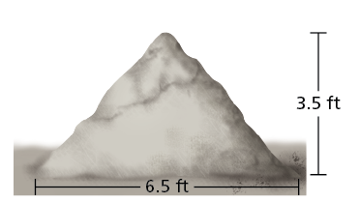
8.5 ft
6.5 ft

Name: ___________________________________________ Table #: ______ Period: _______ Date: _______
KLA #4_Quiz 8.1-8.2
Use pi to solve each problem.
Circle the problem numbers you missed on Quiz (8.1-8.2). (Go to “Reports”; then “Review” in BIM)
1. | 2.
3. | 4.
5. | 6.
8. | 9.
10. | 7. extra credit
Name: ___________________________________________ Table #: ______ Period: _______ Date: _______
KLA #4 RETAKE_Quiz 8.1-8.2
1. | 2.
3. | 4.
5. | 6.
8. | 9.
10. | 7. extra credit

