Name Date

Practice 8.1-8.2 Review NOTES

For use after Lesson 8.1

8.1

Do not use 3.14. Use pi on the calculator or google.

Find the volume of the cylinder. Round your answer to the nearest tenth.

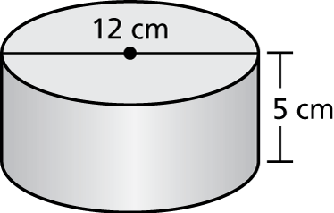 1. 2. 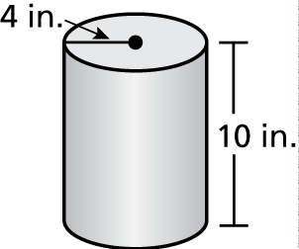

Find the missing dimension of the cylinder. Round your answer to the nearest whole number.

3.  4. 

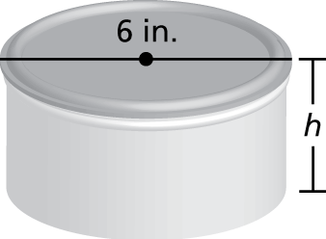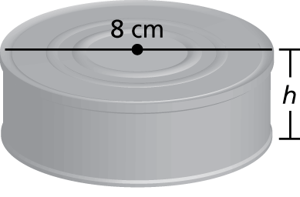

5. To make orange juice, the directions call for a can of orange juice concentrate to be mixed with three cans of water. What is the 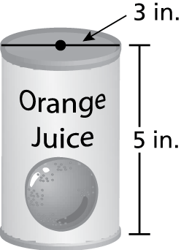  
volume of orange juice that you make?

BACK 🡪

Name Date

Practice

For use after Lesson 8.2

8.2

Find the volume of the cone. Round your answer to the nearest tenth.

1. 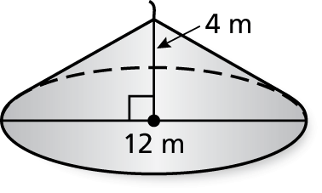 2. 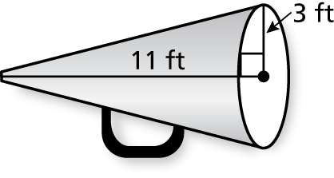 3. 