Name: __________________________ Table #: __________ Period: _____ Date: ______
8.1A Circles and Circumference_Classwork
Objective: find radius and diameter, find the circumferences of circles
CC.SS.7.G.4; MP8 Look for and Express Regularity in Repeated Reasoning. HW: 8.1A page 321 #1-11 ALL

A circle is the set of all points in a plane that are the same distance from a point called the center.
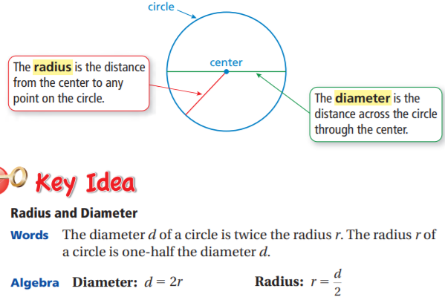

- Finding a Radius and a Diameter: The diameter of a circle is 20 feet. Find the radius. | - Finding a Radius and a Diameter: The radius of a circle is 7 meters. Find the diameter.
CIRCUMFERENCE of A CIRCLE
The circumference C of a circle is equal to _________________________________________________________

______________________________________________________________. It is another word for perimeter.

FORMULA
Circumference: __________________________ or __________________________

- Finding Circumferences of Circles: Find the circumference of the flying disc with a radius of 5 in. Use 3.14 for $π$ | - Finding Circumferences of Circles: Find the circumference of the watch face with a diameter of 28 mm. Use 3.14 for $π$.
- Consider the circles A, B, C, and D.
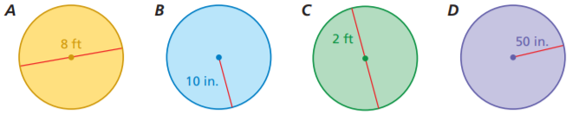
- Without calculating, which circle has the greatest circumference? ________________________________
- Without calculating, which circle has the least circumference? ___________________________________

- Estimate the diameter given a circumference of 28.26 meters. | - Estimate the diameter given a circumference of 12.56 inches.
- Estimate the radius given a circumference of 28.26 meters. | - Estimate the radius given a circumference of 12.56 inches.
- A circular sinkhole has a circumference of 75.36 meters. A week later, it has a circumference of 150.42 meters.
- Estimate the diameter of the sinkhole each week. ___________________________________

- How many times greater is the diameter of the sinkhole now compared to the previous week?
____________________________

PRACTICE PROBLEMS: draw out the diagram, show your work, round your answer to the nearest tenth, use 3.14 for , and include unit to the answer
- Mr. Sam is putting a trim around the edge of a circular merry-go-around that has a diameter of 15 feet. How much trim does he needs to buy? | - Find the circumference of a pizza with a radius of 6 inches.
- Find the circumference  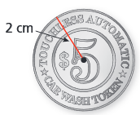 | - Find the circumference  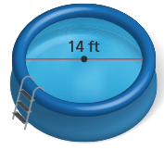

Resources:
https://www.lcps.org/cms/lib4/VA01000195/Centricity/Domain/10878/AreaCircNotesandHW.pdf

