Name: _________________________ Table #: _______ Period: ______ Date: ______
8.1A NOTES – Volumes of Cylinders
Objective: Find the volume of a cylinder. Solve word problems involving volume of cylinders. CCSS: 8.G.9
HW: (8.1A) p. 338 #3-12 all.

YOU TUBE VIDEO: https://www.youtube.com/watch?v=Bb_XJ7UPDlM
**READ Examples 1 on p. 336** WHEN CALCULATING USE “$π$”
FORMULA FOR VOLUME OF A CYLINDER: $V= πr^{2}h$

FIND THE VOLUME FOR THE CYLINDERS. ROUND TO THE NEAREST TENTH.
1  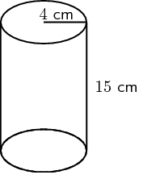 | 2  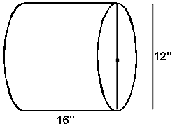
3  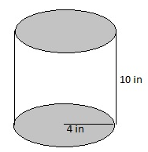 | 4  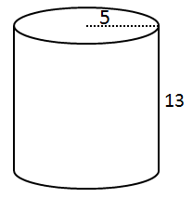
Example 1: HOW MUCH SALSA IS MISSING FROM THE JAR?
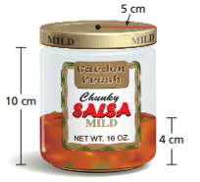

The height of the jar is ____ cm.

There is ___ cm of salsa remaining in the jar.

Therefore the empty space is _________________.

The radius of the jar is _______ cm.

The VOLUME FOR THE EMPTY SPACE IS …

BACK
Example 2: About how many gallons of water does the watercooler bottle contain? $\left(1 {ft}^{3}≈7.5 gal.\right)$ Round to the nearest gallon.
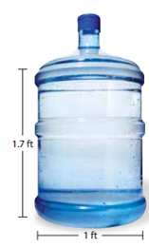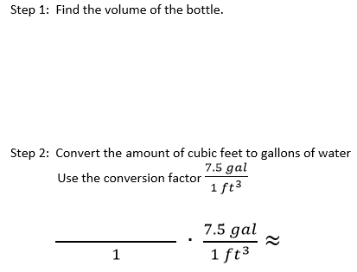

1. A jelly jar has a radius of 3 centimeters and a height of 8 centimeters. The jelly remaining in the jar has a height of 3 centimeters. How much jelly is missing from the jar? Round your answer to the nearest tenth.

2. A cylindrical tower has a diameter of 15 meters and a height of 5 meters. About how many gallons of water can the tower contain? (1 m³ $≈$ 264 gal). Round your answer to the nearest gallon.

Solutions: * my answer is in pi NOT 3.14
1. about 141.4 cm³ 2. 233,263 gal

My Favorite Mistake
Find the volume of the cylinder
