Name: ____________________________ Table #: _______ Period: ______ Date: _____
8.1A Volumes of Cylinders_Classwork
Objective: Find the volume of a cylinder. Solve word problems involving volume of cylinders. CCSS: 8.G.9
YOUTUBE VIDEO: https://www.youtube.com/watch?v=Bb_XJ7UPDlM
**READ Examples 1 and 2 on p. 336**

FORMULA FOR VOLUME OF A CYLINDER: $V= πr^{2}h$

FIND THE VOLUME FOR THE CYLINDERS. ROUND TO THE NEAREST TENTH.
1  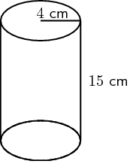 | 2  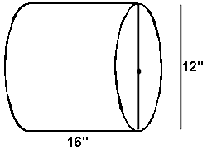
3  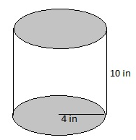 | 4  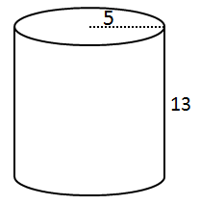
Example 1: HOW MUCH SALSA IS MISSING FROM THE JAR?
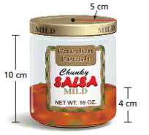

The height of the jar is ____ cm.

There is ___ cm in length of salsa remaining in the jar.

Therefore the empty space height is _________________.

The radius of the jar is _______ cm.

The VOLUME FOR THE EMPTY SPACE IS …

BACK
Example 2: About how many gallons of water does the watercooler bottle contain? $\left(1 {ft}^{3}≈7.5 gal.\right)$ Round to the nearest hundredth.
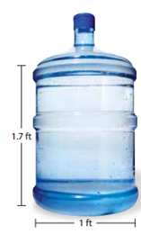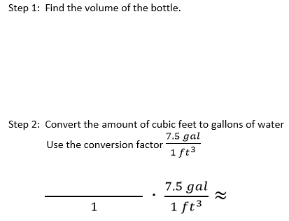
1. A jelly jar has a radius of 3 centimeters and a height of 8 centimeters. The jelly remaining in the jar has a height of 3 centimeters. How much jelly is missing from the jar?

2. A cylindrical tower has a diameter of 15 meters and a height of 5 meters. About how many gallons of water can the tower contain? (1 m³ $≈$ 264 gal).

Solutions: 1. about 141.4 cm³ 2. 233,263 gal

