Name: __________________________ Table #: __________ Period: _____ Date: ______
8.1B Circles and Circumference_Classwork
Objective: find the perimeters of semicircles, find the circumferences of circles
CC.SS.7.G.4; MP8 Look for and Express Regularity in Repeated Reasoning HW: 8.1B page 322_#13-19 ALL

SEMICIRCLE
A semicircle is ________________________________________________________________________________.

Perimeter is _________________________________________________________________________________.

To find the perimeter of a semicircular region you ___________________________________________________.

- Find the perimeter of the semicircular region. Round answer to the nearest tenth and use 3.14 for pi.  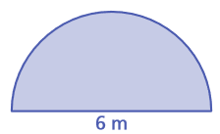 | - Find the perimeter of the semicircular region. Round answer to the nearest tenth and use 3.14 for pi.  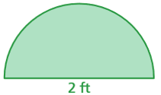
- Find the perimeter of the semicircular region. Round answer to the nearest tenth and use 3.14 for pi.  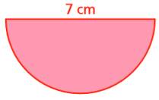 | - A wire is bent to form four semicircles. How long is the wire? Round to the nearest tenth and use 3.14 for pi.  24 cm  24 cm
- Find the circumference of both circles. Round answer to the nearest tenth and use 3.14 for pi.
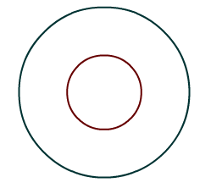
2 cm
Small Circle | Big Circle

2 cm

- Find the circumference of both circles. Round answer to the nearest tenth and use 3.14 for pi.
Small Circle | Big Circle

3 ft
1.5 ft

- Find the circumference of both circles. Round answer to the nearest tenth and use 3.14 for pi.
Small Circle | Big Circle

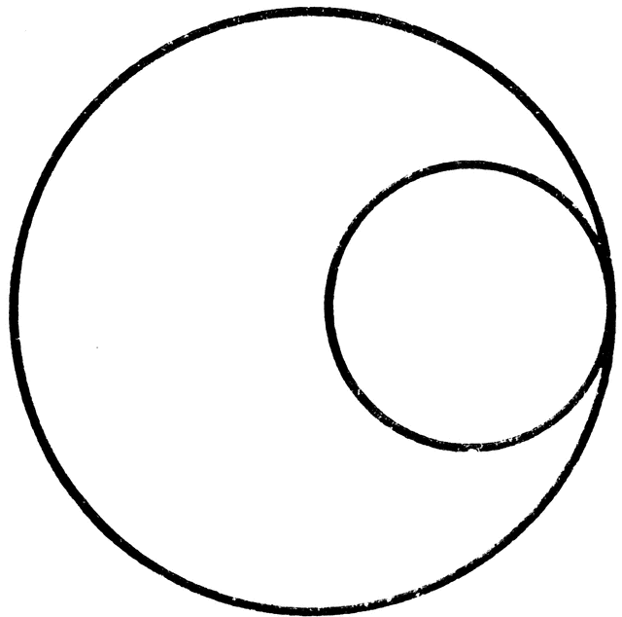
12 m

