Name: _________________________ Table #: _______ Period: ______ Date: ______
8.1B NOTES – Volumes of Cylinders
Objective: find the volumes of cylinders; find the heights of cylinders given the volumes; solve real-life problems. CC.SS.8.G.9 HW: 8.1B Homework (handout)

** Start with warm up on the back**
FORMULA FOR VOLUME OF A CYLINDER: $V= πr^{2}h$
EXAMPLES. Find the missing dimension of the cylinder given the volume.
Round to the nearest hundredth.
1. Find the height of the cylinder with the given volume and diameter.
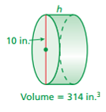

2. The volume of a cylinder is $405π {cm}^{3}$ and the radius is 9cm. Find the height.

3. Find the radius of a cylinder with a volume of 7,065 ft³ and a height of 10 ft.

ON YOUR OWN
- Find the height for the given diameter and volume. Round to the nearest hundredth.
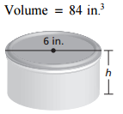

BACK
- Find the height for the given diameter and volume. Round to the nearest hundredth.
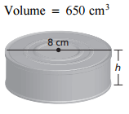

- Find the height of a cylinder with volume of $324π$ cm³ and radius of 6 cm. Round to the nearest hundredth.

- Find the radius of a cylinder with a volume of 3,768 ft³ and a height of 12 ft. Round to the nearest hundredth.

- Find the radius. Round your answer to the nearest whole number.
$$Volume=8,000π{ cm}^{3}$$
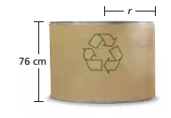
40 cm

