Name: ____________________ Table #: _______ Period: ______ Date: ______
8.1B Volumes of Cylinders_Classwork

Objective: find the volumes of cylinders; find the heights of cylinders given the volumes; solve real-life problems. CC.SS.8.G.9
HW: BIM pg 338 #6-15 ALL
*******************************WARM UP******************************************
- Find the volume of a cylinder with a diameter of 16cm and height of 4cm. | - Find the volume of a cylinder with a diameter of 8cm and height of 4cm. | - How does the volume of a cylinder change when its diameter is halved? Explain.

Find the missing dimension of the cylinder given the volume.
1. Find the height of the cylinder with the given volume and diameter.
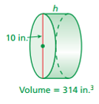

2. The volume of a cylinder is $405π {cm}^{3}$ and the radius is 9cm. Find the height.

3. Find the radius of a cylinder with a volume of 7,065 ft³ and a height of 10 ft.

BACK
FORMULA FOR VOLUME OF A CYLINDER: $V= πr^{2}h$

- Find the height for the given diameter and volume. Round to the nearest hundredth.  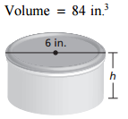 | - Find the height for the given diameter and volume. Round to the nearest hundredth.  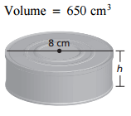
- Find the height of a cylinder with volume of $324π$ cm³ and radius of 6 cm. | - Find the radius of a cylinder with a volume of 3,768 ft³ and a height of 12 ft.

Find the missing dimension of the cylinder. Round your answer to the nearest whole number.
- $Volume=400π{ ft}^{3}$
6 ft
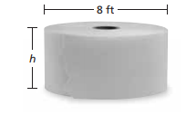
- $Volume=25,000π{ in}^{3}$
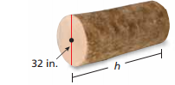
20 in

- $Volume=80,000π{ cm}^{3}$
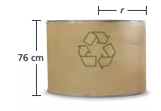
40 cm
Solution: 1) $≈2.97in$ 2) $≈12.93cm$ 3) $9cm$ 4) $≈10ft$
5) $≈44ft$ 6) $250in$ 7) $≈45cm$

