Name: ____________________ Table #: _______ Period: ______ Date: ______
8.2A NOTES – Volumes of Cones

Objective: find the volumes of cones; find the heights of cones given the volumes; solve real-life problems.
CC.SS.8.G.9 (MP4 Model with Mathematics) HW: BIM 8.2A pg 344 #4-12 all, 14 (solution on pg A34)

FORMULA FOR VOLUME OF A CONE: $V=(πr^{2}h)÷3 or V= \frac{πr^{2}h}{3}$
FIND THE VOLUME FOR THE CONES. ROUND TO THE NEAREST TENTH.
1  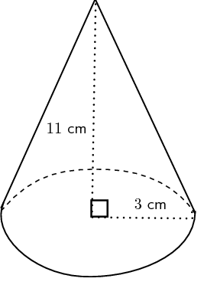 | 2  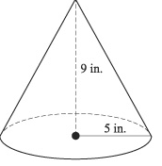
3  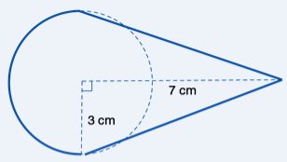 | 4  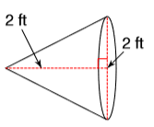
5.  The base of a cone shaped glass is 10 inches and it is 16 inches tall. You fill the glass with soda pop to the top of the glass. What is the volume of soda pop? Round to the nearest tenth. | 6.  A tee-pee is in the shape of a cone. The tee-pee is 8.5 feet high, 20 feet long. Find the volume of air that occupies the house, assuming it is empty. Round to the nearest tenth.
BACK
WARM UP
- Similar Test Question #15: A packaging company makes package peanuts in two containers, rectangular prisms and cylinders. The rectangular prism has a length of 6 feet, a width of 3 feet, and a height of 5 feet. The cylinder of peanuts has a diameter of 7 feet and a height of 10 feet. How many rectangular prisms contain the same amount of peanuts as one cylinder container? Round your answer to the nearest tenth.

- Similar Test Question #16: A swimming pool shaped like a cylinder has a diameter of 15 feet and a height of 5 feet. How many gallons of water can the pool contain? Round your answer to the nearest whole number. (1 ft³ $≈$7.5 gal.)

++++++++++++++++++++++++++++++++++++++++++++++++++++++++++++++++++++++++++++++++++++++++++++++
https://www.youtube.com/watch?v=xwPiA0COi8k
https://www.youtube.com/watch?v=vCJ-zRQSguQ

CLASS NOTES
A) B)
