Name: ____________________________ Table #: ______ Period: ____ Date: ____

**8.2A Perimeters of Composite Figures**

*Objective: find perimeters of composite shapes. CC.SS.7.G.4*

*HW: textbook: 8.2A pg 328_#9-16 ALL, #20-24 ALL*

|  |  |
| --- | --- |
|  |  |
| **14 yd** |  |
|  |  |
|  |  |
|  |  |

# PROBLEM 1

The diagram at the right gives the dimensions of a swimming pool. How many feet of metals do you need to buy to have the fence around the pool?

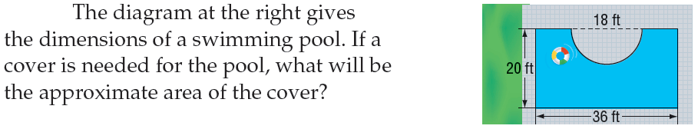

ANSWER: You need to buy ____________________ of metals to have the fence around the pool.

# ++++++++++++++++++++++++++++++++++++++++++++++++++++++++++++++++++++++++++++++++++++++

# PROBLEM 2

A farmer wants to fence a section of land for a horse pasture. Fencing costs $15 per yard. How much will it cost to fence the pasture? HINT: 3 feet = 1 yard

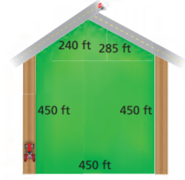

ANSWER: It costs _______________ to fence the pasture.

**++++++++++++++++++++++++++++++++++++++++++++++++++++++++++++++++++++++++++++++++++++++++++++++**

# PROBLEM 3

The school’s athletic director wants to replace the fence. The field is shown at right.



50 m

A. How many meters of fencing will he need to purchase?

B. If fencing costs $23.50 per meter, how much will it cost to replace the fence for the field?

ANSWER: It costs ________________ to replace the fence for the field.