Name: ____________________________ Table #: _______ Period: ______ Date: _____
8.2B NOTES – Volumes of Cones
Objective: find the volumes of cones, find the heights of cones given the volumes, solve real-life problems (CC.SS.8.G.9_MP4 Model with Mathematics)
Video: https://www.youtube.com/watch?v=2T7YxFVCVwI or https://www.youtube.com/watch?v=Ex-peEPTWGI
FORMULA FOR VOLUME OF A CONE:
$V=\frac{1}{3}πr^{2}h or V= \frac{πr^{2}h}{3}$ or $V=\left(πr^{2}h\right)÷3$

FIND THE HEIGHT OF THE CYLINDER GIVEN VOLUME & RADIUS OR DIAMETER.
Round to the nearest hundredth.
EXAMPLE NOTES
1.  Find the height. | 2.  Find the height of a cone with a diameter of 0.1 meter and a volume of 78.5 cm³.

- Find the height.  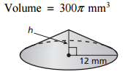 | - Find the diameter of a cone with a volume of 3,768 cm³ and a height of 9 cm.
3. Find the diameter of a cone with a volume of 1,256 in³ and a height of 1 foot.

HW: 8.2B pg 347_#1-10 ALL (Textbook Quiz 8.1-8.2 questions) BACK
- You must answer a trivia question before the sand in the timer falls to the bottom. The sand falls at a rate of 50 cubic millimeters per second. How much time do you have to answer the question? Round to the nearest hundredth.
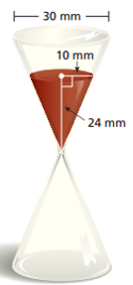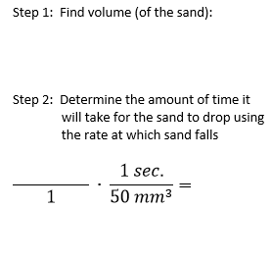
- Similar Test Question #17. LEMONADE STAND: You have 10 gallons of lemonade to sell. ($1 gal≈{3785 cm}^{3}$)

- Each Customer uses one paper cup. How many paper cups will you need? _____________

- The cups are sold in packages of 50. How many packages should you buy? _____________

- Find the Height. Round to the nearest tenth.  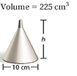 | - Find the diameter. Round to the nearest tenth.  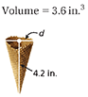
Name: ____________________________ Table #: _______ Period: ______ Date: _____
8.2B HOMEWORK – Volumes of Cones

HW: 8.2B pg 347_#1-10 ALL (Quiz questions)
Find the volume of the solid. Round your answer to the nearest tenth.
1.  12 ft  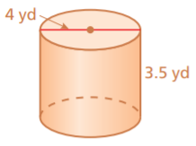 | 2.  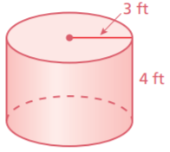
3.  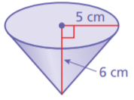 | 4.  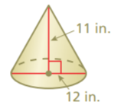
Find the missing dimension of the solid. Round your answer to the nearest tenth.
5.  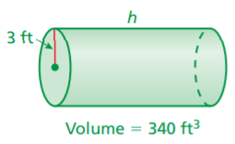 | 6.  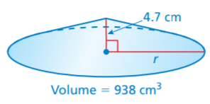

BACK

7.  PAPER CONE: The paper cone can hold 84.78 cubic centimeters of water. What is the height of the cone?  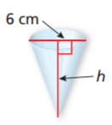 | 8.  GEOMETRY: Triple both dimensions of the cylinder. How many times greater is the volume of the new cylinder than the volume of the original cylinder?  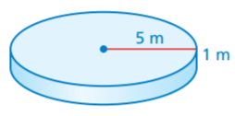
9.  SAND ART: There are 42.39 cubic inches of blue sand and 28.26 cubic inches of red sand in the cylindrical container. How many cubic inches of white sand are in the container?  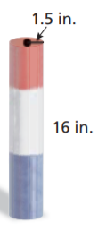 | 10.  JUICE CAN: You are buying two cylindrical cans of juice. Each can holds the same amount of juice. What is the height of Can B?  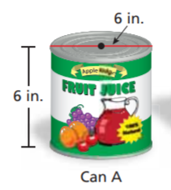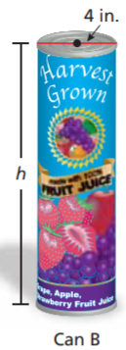

SOLUTIONS: 1) $≈44.0 {yd}^{3}$ 2) $≈113.1 {ft}^{3}$ 3) $≈157.1 {cm}^{3}$ 4) $≈414.7 {in}^{3}$ 5) $≈12.0 ft$
6) $≈13.8 cm$ 7) $≈9 cm$ 8) 27 times greater 9) $≈42.45 {in}^{3}$ 10) $13.5 in$

