Name: ____________________________ Table #: _______ Period: ______ Date: _____
8.2B Volumes of Cones_Classwork
Objective: find the volumes of cones, find the heights of cones given the volumes, solve real-life problems (CC.SS.8.G.9_MP4 Model with Mathematics)
Video: https://www.youtube.com/watch?v=2T7YxFVCVwI or https://www.youtube.com/watch?v=Ex-peEPTWGI
FORMULA FOR VOLUME OF A CONE:
$V=\frac{1}{3}πr^{2}h or V= \frac{πr^{2}h}{3}$ or $V=\left(πr^{2}h\right)÷3$

FIND THE HEIGHT OF THE CYLINDER GIVEN VOLUME & RADIUS OR DIAMETER.
Round to the nearest hundredth.
EXAMPLE NOTES
1.  Find the height. | 2.  Find the diameter of a cone with a volume of 3,768 cubic centimeters and a height of 9 cm.

1. Find the height.  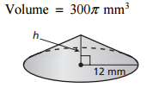 | 2. Find the height.  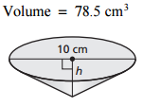
3. Find the diameter of a cone with a volume of 1,256 in³ and a height of 12 in.

HW: (8.2B) p. 347 (#1-8, 10) Solution: 1) $≈44{ yd}^{3}$ 2) $≈113.1{ ft}^{3}$ 3) $≈157.1 {cm}^{3}$ 4) $≈414.7 {in}^{3}$ 5) $≈12 ft$ 6) $≈13.8 cm$ 7) $≈9cm$ 8) $27 times greater$ 10) $13.5in$
- You must answer a trivia question before the sand in the timer falls to the bottom. The sand falls at a rate of 50 cubic millimeters per second. How much time do you have to answer the question? Round to the nearest hundredth.
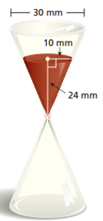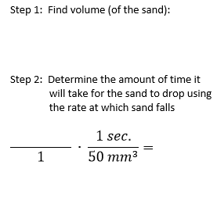
- LEMONADE STAND: You have 10 gallons of lemonade to sell. ($1 gal≈{3785 cm}^{3}$)

- Each Customer uses one paper cup. How many paper cups will you need? _____________

- The cups are sold in packages of 50. How many packages should you buy? _____________

- Find the Height. Round to the nearest tenth.  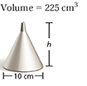 | - Find the diameter. Round to the nearest tenth.  