Name: __________________________ Table #: _____________ Period: ______ Date: _________
8.3A Area of Circles and Semicircles_Classwork
Objective: find area of semicircles CC.SS.7.G.4_MP4 Model with Mathematics
HW- 8.3A worksheet
AREA OF A CIRCLE
To find the area of a circle you: __________________________________________________________________

Find the area of the circles. Round the answer to the nearest tenth. Use 3.14 as pi.

AREA OF A SEMICIRCLE
To find the area of a semicircle you: _____________________________________________________________

Find the area of the semicircular regions. Round the answer to the nearest tenth. Use 3.14 as pi.
- The area of the orchestra pit is one-half the area of a circle with a diameter of 30 feet. Find the area of the orchestra.
16 in

Practice Problems
Find the area. Round the answer to the nearest tenth. Use 3.14 for pi.
- Susan designed a circular pool with a diameter of 25 meters. What is the area of the bottom of the pool? | - Find the area of the penny.  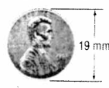
- What is the area of the drumhead on the drum shown below?  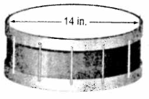 | - Estimate the area of the top of a round pizza that has a radius of 9 inches.
- Sally needs to buy paint for her circular wood. The dimensions is 3.5 yards in radius. How much blue paint does Sally need to buy to cover the wood? | - What is the area of the top surface of a circular dish that has a radius of 12 inches?
- Jane needs to buy paint for her circular wood. The dimensions is 5.5 yards in radius. How much red paint does Jane need to buy to cover only half of the wood? | - What is the area of the top surface of a semicircular window that has a diameter of 33 inches?

