Name Date

**8.3A HW**

1. Find the diameter of the circle. 2. Find the radius of the circle.

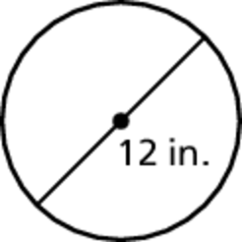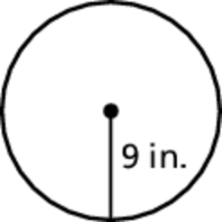

Find the circumference of the circle. Use 3.14 for**

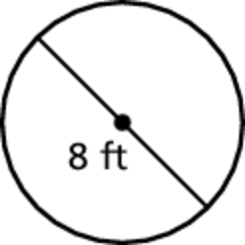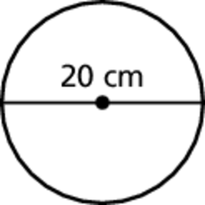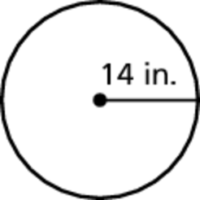 3. 4. 5.

Find the perimeter of the semicircular region.

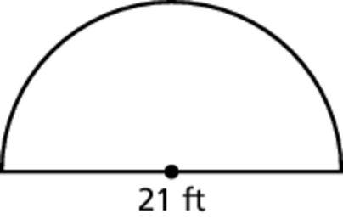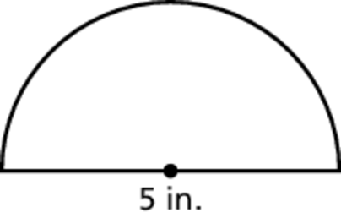 6. 7.

8. A simple impact crater on the moon has a diameter of 15 kilometers.   
A complex impact crater has a radius of 30 kilometers. How much   
greater is the circumference of the complex impact crater than the   
simple impact crater?

**BACK 🡪**

Name Date

Practice

For use after Lesson 8.3

8.3

Find the area of the circle. Use 3.14 for

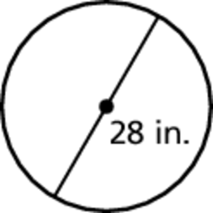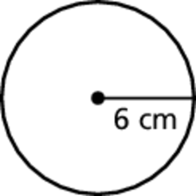 1. 2.

Find the area of the semicircle.

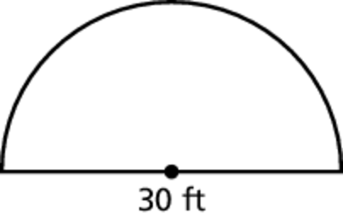 3. 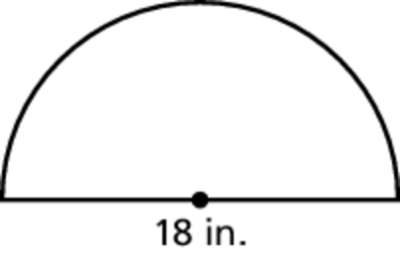 4.

5. An FM radio station signal travels in a 40-mile radius. An AM radio station signal travels in a 4-mile radius. How much more area does the FM station cover than the AM station?