Name: ____________________________ Table #: ______ Period: ____ Date:___
8.3A NOTES – Volume of Spheres

Objective: Students can use the formula for volume of a sphere to find the volume and the radius. CCSS: 8.G.9
HW: (8.3A) p. 352 #3 – 13 (solutions on p. A35)
https://www.youtube.com/watch?v=YNutS8eIhEs#t=4.083671
FORMULA FOR VOLUME OF A SPHERE:
$V= \frac{4πr^{3}}{3}$ or $V= \left(4πr^{3}\right)÷3$ or $V=\frac{4r^{3}}{3}π$
Find the volume V or radius r of the sphere. Round your answer to the nearest tenth, if necessary.
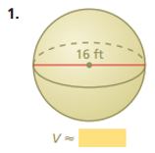 | 1b. A snow globe has a diameter of 3cm. What  is the volume of the snow globe?
2a. Find the radius of the sphere with the given  volume. VOLUME = 288$π$ m³ | 2b. A softball has a volume of $\frac{343}{6}π$ cubic inches.  Find the radius of the softball.

3. You have an ice cream scoop with a 2-inch diameter. You have an ice cream cone with a 2-inch
diameter and a height of 5 inches. If you place one scoop of ice cream on the cone and let the
ice cream melt, will it spill over the cone? Explain.

Warm Up
- The cylinder and cone have the same volume. What is the height of the cone?
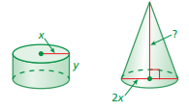

- Mr. Ben measures water running into a cylindrical pool. He calculates the rate at 5000 cubic inches per minute. The pool has a diameter of 160 inches and a height of 60 inches. What is the height, in inches, of the water in the pool after 10 minutes? Round your answer to the nearest tenth.

- Solve the equation
$$\frac{7}{8}x= \frac{343}{4}$$

EXAMPLE 1:  Finding the Volume of a Sphere. Round the answer to the nearest tenth.  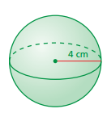 | EXAMPLE 2:  Finding the Radius of a Sphere. Volume is $972π{ in}^{3}$ | EXAMPLE 3:  Find the radius of a sphere with volume $\frac{729}{6}π { in}^{3}$

