Name: __________________________ Table #: _____________ Period: ______ Date: _________
8.3B Area of Circles_Classwork

Objective: use inductive reasoning to understand the formula for the area of a circle
CC.SS.7.G.4_MP4 Model with Mathematics HW: textbook – 8.3B pg 336 #3-15 ALL

Problem 1: A dog is leashed to the corner of a house. How much running area does the dog have? Explain how you found your answer.
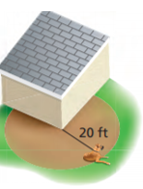

Problem 2: Find the area of the shaded region. Explain how you found your answer.  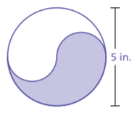 | Problem 3: Find the area of the shaded region. Explain how you found your answer.  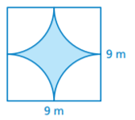
Problem 4: Consider five circles with radii of 1, 2, 4, 8, and 16 inches.  - Complete the table. Write your answers in terms of $π$.  - Compare the areas and circumferences. What happens to the circumference of a circle when you double the radius?  - What happens to the area of a circle when you double the radius? | 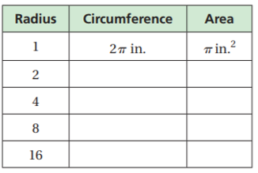
Area Formula Activity

What is the name of this shape?

What is the formula to find the area of this shape?

What is the name of this shape?

What is the formula to find the area of this shape?

What is the defintion of circumference?

THE AREA OF A CIRCLE: ____________________
Part A:
Cut the circle into 16 parts and rearrange the pieces into another simple shape.
Part B:
Draw the shape here

- Can you identify the new shape that you have created?

- What is the approximate height and base of the new shape?

BASE = ____________________ and HEIGHT: ____________________

- Find the area of the new shape. What can you conclude?

Part C:
- IN YOUR OWN WORDS. Based on what you have done with the activity, how can you find the area of a circle?

