Name: ________________ Table #: _______ Period: ______ Date: ____
8.3B NOTES Composite Solids
Objective: find the volumes of composite figures using volumes of other basic figures. CC.SS.8G.9
HW: 8.3B HW and Review (handout)

DIRECITONS: FIND THE VOLUME OF THE COMPOSITE SOLID.
EXAMPLE 1: Finding the Volume of a Composite Solid
A hemisphere is one-half of a sphere. The top of the silo is a hemisphere with a radius of 12 feet. What is the volume of the silo? Round your answer to the nearest thousand.

The silo is made up of a cylinder and a hemisphere. Find the volume of each solid.
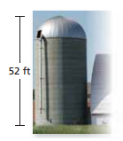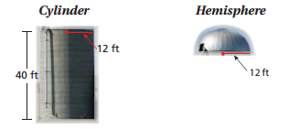

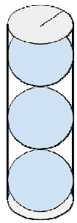 | EXAMPLE 2: Similar Test Question #19: A tennis ball with a 3 inch diameter is sold in cans of three. The can is a cylinder. Round to the nearest tenth.  - What is the volume of one tennis ball? ____________  - What is the volume of 3 balls? ______________  - What is the volume of the cylinder? ____________  - How much space is not occupied by the tennis balls in the can? ________
BACK
Similar Test Question #11: Water flows at a rate of 8,000 cubic inches per minute into a cylindrical tank. The tank has a diameter of 160 inches and a height of 40 inches. What is the height, in inches, of the water in the tank after 10 minutes? Round your answer to the nearest tenth.

PRACTICE PROBLEMS
DIRECITONS: FIND THE VOLUME OF THE COMPOSITE SOLID. ROUND THE ANSWER TO THE NEAREST TENTH.
COMPOSITE FIGURES | Draw into smaller BASIC FIGURES. | Find the volume of each BASIC FIGURE. | ADD the volume of all of the figures.
1.
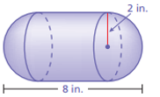

2.
