Name: _______________________ Table# ____ Period: ______ Date: _______
8.3B Homework
FIND THE VOLUME OF THE COMPOSITE SOLIDS. ROUND YOUR ANSWER TO THE NEAREST TENTH. USE PI
1.  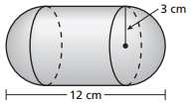 | 2.  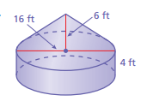
3.  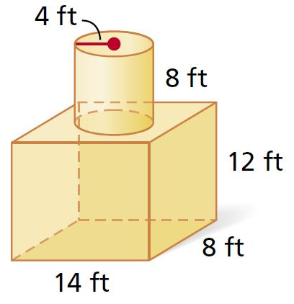 | 4.  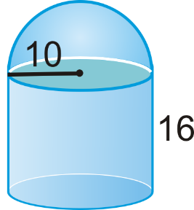
BACK
- Water flows at a rate of 5,000 cubic inches per minute into a cylindrical tank. The tank has a diameter of 100 inches and a height of 30 inches. What is the height, in inches, of the water in the tank after 8 minutes? Round your answer to the nearest whole number.

- A cylindrical swimming pool has a diameter of 18 feet and a height of 5 feet. About how many gallons of water can the pool contain? Round your answer to the nearest whole number.
1 cubic foot is about 7.5 gallons of water.

Solutions: 1) 90$π≈$ 282.7 cm³ 2) 384$π≈$1206.4 ft³ 3) 1,746.1 ft³ 4) $\frac{13,600π}{6}≈7120.9{ u}^{3}$ 5) 5 inches 6) $≈$9,543 gal.

