Name: ________________________ Table #: ______ Period: ____ Date:___
8.4A NOTES – Solid Figures
Objective: identify similar solids; use properties of similar solids to find missing measures CC.SS.8.G.9
FRIDAY CW: (8.4A) BIM p. 359 # 4-9 all (submit online)

***Do Review Problems on the back***
LIST THE THREE WAYS YOU CAN DETERMINE THAT TWO RATIOS ARE PROPORTIONAL:
1.
2.
3.

SIMILAR SOLIDS have the same shape and PROPORTIONAL corresponding dimensions.
1. Is Prism A similar to Prism B?  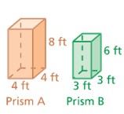 | 2. Is Prism A similar to Prism C?  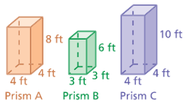
3.  The square pyramids are similar. Find the length of the base of Pyramid E.  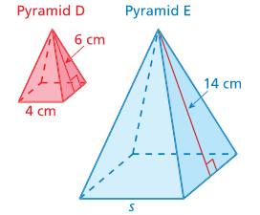 | 4.  The prisms at the right are similar. Find the missing width and length.  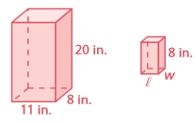
BACK
Example 1: Which cylinder is similar to Cylinder A?
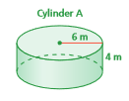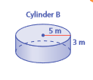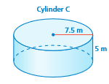
Is Cylinder A similar to Cylinder B?
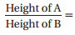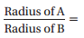

Is Cylinder A similar to Cylinder C?
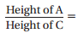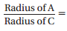

Example 2: The cones are similar. Find the missing slant height (L).

REVIEW PROBLEMS.
- Simplify both ratios (fractions) to determine if they are equivalent.
- $\frac{8.5}{17} \& \frac{9}{18}$ b. $\frac{39}{13 } \& \frac{43.4}{14}$

- Fill in the blanks for the PROPORTIONAL SEQUENCE

$$\frac{3}{5}= \frac{ }{10}= \frac{9}{ }= \frac{ }{ 20 }= \frac{ }{ }$$

- Use cross multiplication to determine whether the equation is a proportion.

- $\frac{7}{36} = \frac{17.5}{90}$ b. $\frac{10}{62} = \frac{30}{184}$

8.4A CW QUESTIONS
