Name: _______________________ Table #: _____ Period: __________ Date: ______
8.4B Areas of Composite Figures_Classwork
Objective: find areas of composite figures by separating them into familiar figures.
CC.SS.7.G.6_MP1 Make Sense of Problems of Persevere in Solving Them
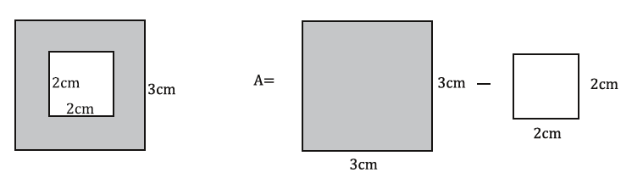
Composite Figures | Draw the BIG figure and the unwanted figure(s) | Find the area of each BASIC FIGURE. | Subtract the whole Basic Shape from the unwanted shape
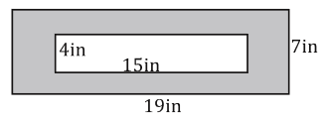

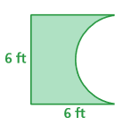
Composite Figures | Draw the BIG figure and the unwanted figure(s) | Find the area of each BASIC FIGURE. | Subtract the whole Basic Shape from the unwanted shape
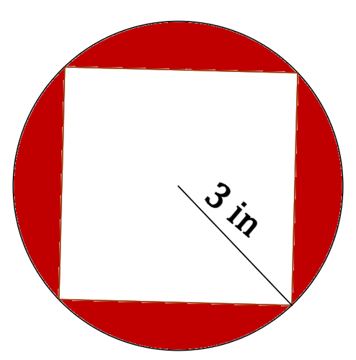
4.5 in
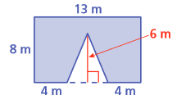
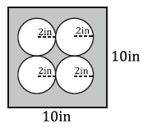

Composite Figures | Draw the BIG figure and the unwanted figure(s) | Find the area of each BASIC FIGURE. | Subtract the whole Basic Shape from the unwanted shape
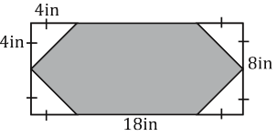
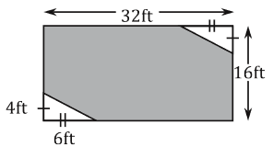
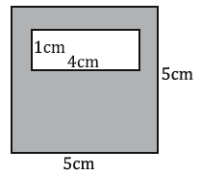

Composite Figures | Draw the BIG figure and the unwanted figure(s) | Find the area of each BASIC FIGURE. | Subtract the whole Basic Shape from the unwanted shape
