Name: _________________ Table #: ______ Period: ______ Date: _______
8.4B NOTES – Surface Areas and Volumes of Similar Solids
Objective: Use properties of similar solids to find missing measures. Understand relationship between volumes of similar solids.

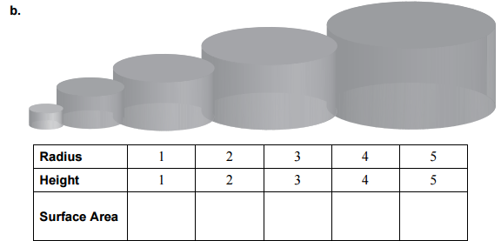
$4π$ $16π$ $36π$ $64π$ $100π$
E
D
C
B
A

Compare the radius of cylinder A to all of the other cylinders (B, C, D & E). Set up a proportion for each one. Simplify any ratios that can be simplified. Are the two ratios equal? Is there a way to make them equal?

$\frac{radius A}{radius B} \frac{surface area A}{surface area B}$ | $\frac{radius A}{radius C} \frac{surface area A}{surface area C}$
$\frac{radius A}{radius D} \frac{surface area A}{surface area D}$ | $\frac{radius A}{radius E} \frac{surface area A}{surface area E}$

When two solids are similar, the ratio of their surface areas is equal to the _________ of the ratio of their corresponding linear measures. ${\left(\frac{a}{b}\right)}^{2}=\frac{surface area of A}{surface area of B}$

BACK
- The solids are similar. Find the surface area of the small solid. Round answers to the nearest tenth.
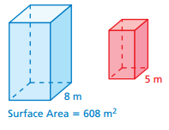
- The solids are similar. Find the surface area of the big solid. Round answers to the nearest tenth.
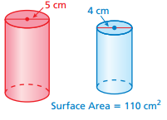
- The pyramids are similar. What is the surface area of Pyramid A?
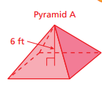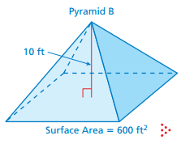

- The pyramids are similar. (a) Find the missing dimension. (b) Find the surface area of big pyramid.
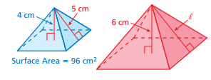

Similar Test Question #14: There are 6 similarly shaped figures in a set. The largest is 6 inches tall. Each of the other figures is 1 inch shorter than the next larger figure. The surface area of the largest figure is 468 in². What is the surface area of the smallest figure? HINT: draw out the figures and include the lengths.

HW: worksheet 8.4B

