Name: _____________________________________________ Per: ____ Table#_____ Date ___________
8.4B Homework – Similar Solids and Surface Area

For #1 – 4: The solids are similar. Find the surface area of the second solid. If necessary, round your answer to the nearest tenth.
1.  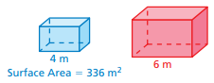  8.4 #10 | 2.  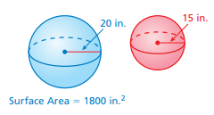  8.4 #11
3.  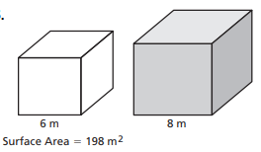  R&P (8.4) | 4.  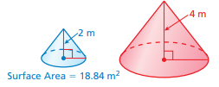  8.3-4 Quiz #8
Continued on back $→$
5.
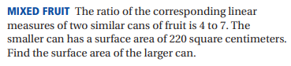

8.4A Review
Two solids are similar if corresponding dimensions are proportional.
There are 3 ways to determine if two ratios are proportional:
- Cross products are equal
- Convert both ratios (fractions) into decimals. If the decimals are equivalent, they are proportional.
- Simplify each ration (fraction). If they are equivalent, they are proportional.

Determine whether the solids are similar.
6.  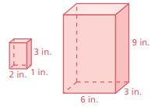  (8.4) p. 359 #4 | 7.  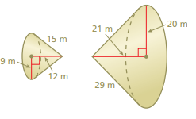  (8.4) p. 359 #7

Solutions: 1) 756 m² 2) 1012.5 in² 3) 352 m² 4) 75.4 m² 5) 673.8 cm² 6) yes 7) no

