Name: _____________________________________________ Per: ____ Table#_____ Date ___________
8.4C NOTES – Volumes of Similar Solids

Objective: Use properties of similar solids to find missing measures. Understand relationship between volumes of similar solids.
Warm-Up
Determine whether the solids are similar

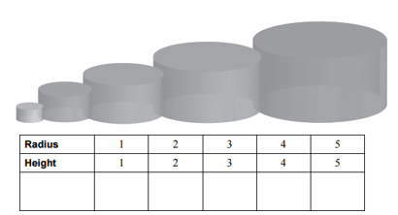
B
A
C
D
E
Volume $π$ $8π$ $27π$ $64π$ $125π$

Compare the radius of cylinder A to all of the other cylinders (B, C, D & E). Set up a proportion for each one. Simplify any ratios that can be simplified. Are the two ratios equal? Is there a way to make them equal?
$\frac{radius of A}{radius of B} \frac{volume of A}{volume of B}$ | $\frac{radius of A}{radius of C} \frac{volume of A}{volume of C}$
$\frac{radius of A}{ radius of D} \frac{volume of A}{volume of D}$ | $\frac{radius of A}{radius of E} \frac{volume of A}{volume of E}$
When two solids are similar, the ratio of their volumes is equal to the _________ of the ratio of their corresponding linear measures. ${\left(\frac{a}{b}\right)}^{3}=\frac{volume of A}{ volume of B}$
The cylinders are similar. Find the volume of Cylinder J. Round your answer to the nearest tenth.
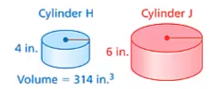

EXAMPLE 4 (p. 358)
The dimensions of the touch tank at the aquarium are doubled. What is the volume of the new touch tank?
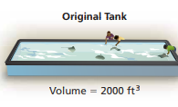

ON YOUR OWN #5 and 6 (p. 358)
The solids are similar. Find the volume of the small solid. Round your answer to the nearest tenth.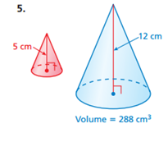

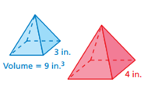
6. The solids are similar. Find the volume of the big solid. Round your answer to the nearest tenth.

HW: (8.4C) p. 360 #10 -15 (ODD Solutions on p. A35)
EVEN SOLUTIONS: 10) 756 m² 12) 196 mm³ 14) Student answers will vary; V = 500 in³

