Name: __________________ Table #: _____ Period: ______ Date: _____
9.1 Scatter Plots_Classwork
Objective: Construct and interpret scatter plots. CCSS: 8.SP.1
HW: textbook- 9.1 pg 376_#3-14 ALL

A scatter plot can show that a relationship exists between two data sets.
FILL IN THE BLANKS.

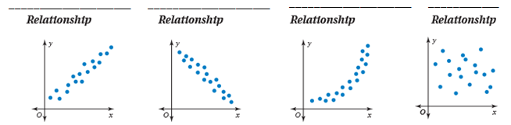

Read Example #2 and answer the questions that pertain to the example.

Describe the relationship between the data. Identify any outliers, gaps, or clusters.

- Television size and price | So the scatter plots shows a … | - Age and number of pets owned | So the scatter plots shows a …

CRITICAL THINKING
- Describe one example of real-life data that has a negative linear relationship.

- Describe one example of real-life data that has a positive linear relationship.

Read Example #1 and answer the questions that pertain to the example.
The scatter plot at the left shows the amounts of fat (in grams) and the numbers of calories in 12 restaurant sandwiches.

- How many calories are in the sandwich that contains 17 grams of fat?
_____________________

- How many grams of fat are in the sandwich that contains 600 calories?
_____________________

- What tends to happen to the number of calories as the number of grams of fat increases?
_________________________________________________
_________________________________________________

- WHAT IF? A sandwich has 650 calories. Based on the scatter plot in Example 1, how many grams of fat would you expect the sandwich to have? Explain your reasoning.

(a) Make a scatter plot of the data.
(b) Describe the relationship between the data. _____________________________________________
(c) Identify any outliers, gaps, or clusters. Outliners: ________________________________________
Gaps: _________________________ Clusters: ________________________________________

A cluster is formed when several data points lie in a small interval.
A gap is an interval that contains no data.
An outlier has a value that is much greater than or much less than other data in the set.

