Name: ________________________________________ Table# ____ Per ____ Date _____________
9.2A Homework (Line of Best Fit)

- The graph shows the weights of dogs and the time it took the same dogs to complete an agility course in seconds. Which shows the line of best fit for the data? EXPLAIN WHY.

______ IS THE BEST LINE OF FIT BECAUSE ___________________________________________

_____________________________________________________________________________
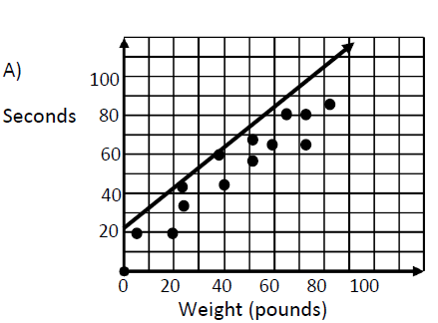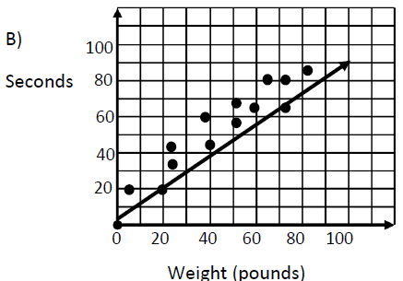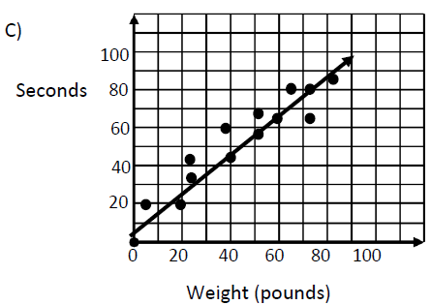

- The scatterplot shows the average yearly consumption of bottled water by people in the U.S. starting in 1990. Using the line of best fit, predict the average consumption of bottled water in the year 2000. EXPLAIN WHY YOU SELECTED YOUR ANSWER. SHOW IT ON THE GRAPH.
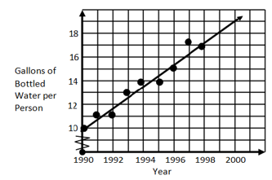

I picked _______ gallons because

___________________________________________

___________________________________________

_____________________________________________

- Chang wants to know if he is improving his skill on the cello. He created a scatterplot and drew a line of best fit. If he uses (2, 8) and (5, 1.5) from his line, which equation would best represent the line of fit? (HINT: Use slope in decimal form. Round your answer to the nearest tenth)
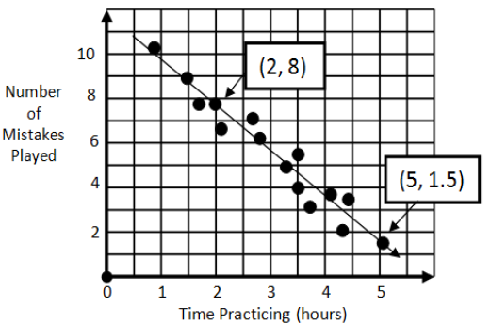

- The scatterplot shows the average price of a major-league baseball ticket from 1997 to 2006.
- Use the points (2001, 17.60) and (2002, 18.85) to write the slope-intercept form equation for the line of fit shown in the scatterplot.
- Use your equation to tell the price of a ticket in 2009.
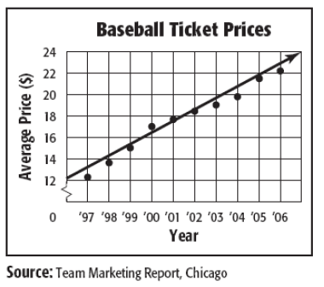

- The table shows the weight y of x bananas.
- Make a scatterplot of the data. Label the axes and give the graph a title.
- Make a line of best fit.
- Write an equation for your line of best fit.
- Use the equation to estimate the weight of 10 bananas.
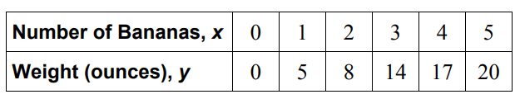

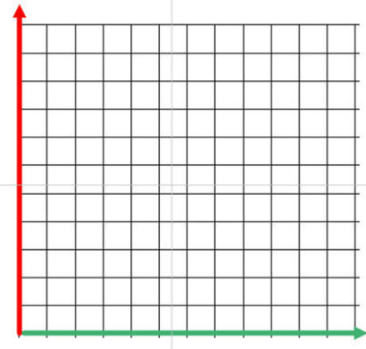

Name: _________________________________________________________ (9.2A)
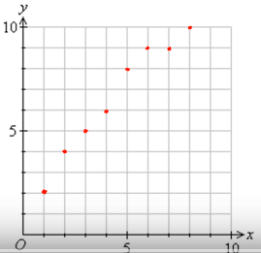
EXPLAIN why you drew that line of best fit the way you did.

Name: _________________________________________________________ (9.2A)
EXPLAIN why you drew that line of best fit the way you did.

- Make a scatter plot of the data and draw a line of fit.
(Label the axes and include a title)
- Write an equation of the line of fit.
- Interpret the slope and the y-intercept of the line of fit.
- Predict how many cats will be adopted in October.

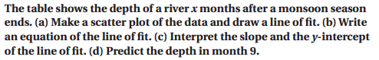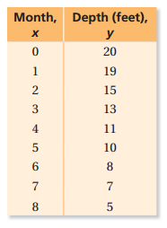
a. Make a scatter plot of the data and draw a line of fit.
(DRAW A LINE THAT IS CLOSE TO THE DATA POINTS. TRY TO HAVE AS MANY POINTS ABOVE
THE LINE AS BELOW IT.)
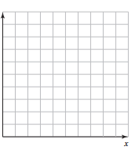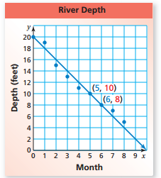
b. Write an equation of the line of fit. (PICK TWO POINTS ON THE LINE OF BEST FIT YOU DREW.
FIND THE SLOPE BETWEEN THE TWO POINTS. USE IT AND THE Y-INTERCEPT TO WRITE THE
EQUATION)

c. Interpret the slope and y-intercept of the line of fit. (Write sentences to describe what the slope
and y-intercept mean in the context of the word problem)

d. Predict the depth in month 9.

