Name: _____________________ Table #: _____ Period: ____ Date: ______
9.2A Surface Areas of Pyramids_Classwork
Objective: find surface are of regular pyramids. CC.SS.7.G.6
HW: 9.2A pg 366_#4-12 ALL
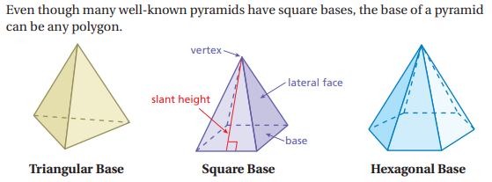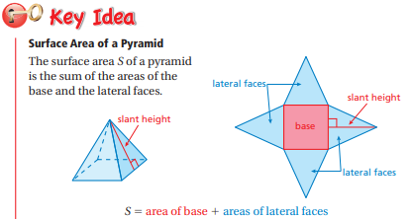
- A _________________________ ________________________ is a pyramid whose base is a regular polygon. The lateral faces are triangle. The height of each triangle is the _______________________ ____________________ of the pyramid.
- A regular polygon is a shape with __________________ sides.

Direction:
- Draw a net of the pyramid.
- Find the lateral surface area of the real-life pyramid.
- Find the surface area of the real-life pyramid.

EXAMPLE 1: Triangular Pyramid

The height of the triangular base is 27m

Lateral surface area: ________ Surface Area of the pyramid: _______

EXAMPLE 2: Hexagonal Pyramid
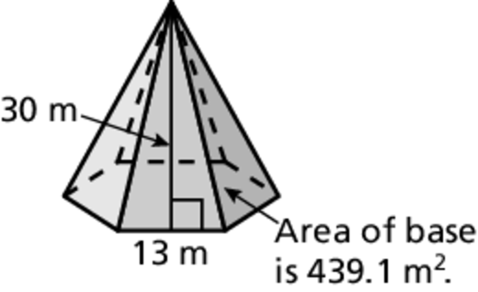

Lateral surface area: ________ Surface Area of the pyramid: _______
Direction:
- Draw a net of the pyramid.
- Find the lateral surface area of the real-life pyramid.
- Find the surface area of the real-life pyramid.
Square Pyramid | Lateral surface area: ________ Surface Area of the pyramid: _______
Square Pyramid | Lateral surface area: ________ Surface Area of the pyramid: _______
c. Triangular Pyramid  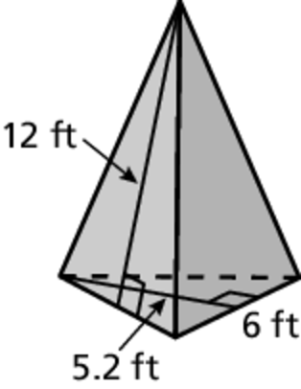 | Lateral surface area: ________ Surface Area of the pyramid: _______
 | UMBRELLA. You are making an umbrella that is shaped like a regular octagonal pyramid. Estimate the amount of fabric that you need to make the umbrella.

