Name: _______________ Table #: ______ Period: _______ Date: ______
9.2B Lines of Fit_Classwork
Objective: Draw a line of fit on a scatter plot. Use the equation of the fit line to solve problems. CC.SS.8.SP.1/2
HW: 9.2B pg 382_#1, 2, 4-7
WARM UP: Given in the table and scatterplot are the samplings of average annual temperatures collected at different elevations in the United States. Pick two points from the line of best fit and determine the slope for it. Compare your result with your table partners: 1) Which slope is better to use?
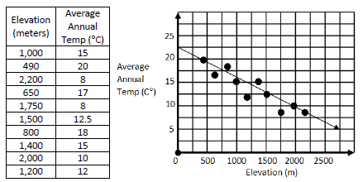
- The table below shows the predicted annual cost for a middle income family to raise a child from birth to adulthood.
- Draw a scatterplot.
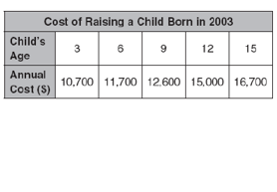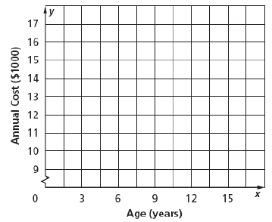

- Describe what correlation exists within the data (Is it positive? Negative? No correlation?).

- Draw a line of best fit and write its equation.

- Interpret the slope and the y-intercept.

- What is the relationship between the price of a book in Canada compared to the price in the U.S.?
- Draw a scatterplot and a line of best fit for the data set below.
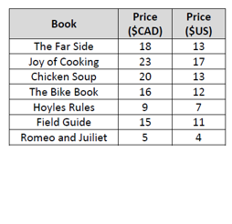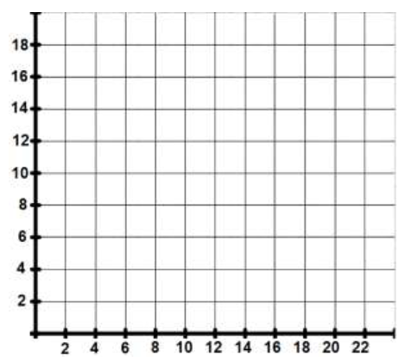
- Describe the correlation.

- Find your line of best fit equation.

- Use your line of best fit (LOBF) equation to determine the price of a U.S. book if it costs $24 CAD.

- Use your LOBF equation to determine the price of a Canadian book if it costs $9 US.

- Sketch a scatterplot that could model each of the scenarios. Include a line of best fit with your scatterplot. Do not forget to label your axes.
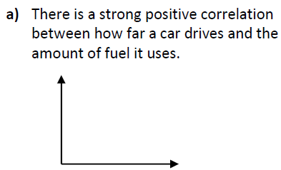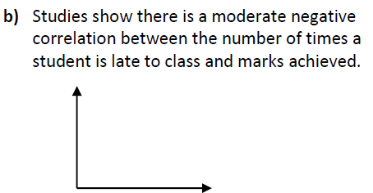

https://www.youtube.com/watch?v=_4F8jeyLie4

