Name: _____________________ Table #: _____ Period: ____ Date: ______
9.3A Surface Areas of Cylinders _Classwork
Objective: find surface area of cylinders. CC.SS.7.G.6
HW: 9.3A pg 372_ #6-13 ALL

WARM-UP
Find the area and circumference for each circle.

Formula for Area = __________________ Formula for Circumference = ___________________________
1.  Area = _______________ Cir = ______________ | 2.  Area = _______________ Cir = ______________

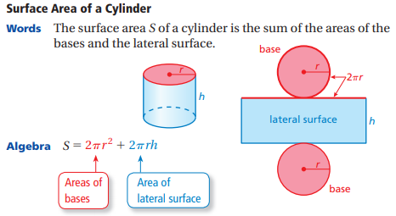
Find the lateral surface area of the cylinder. Round your answer to the nearest tenth.
1. | 2.  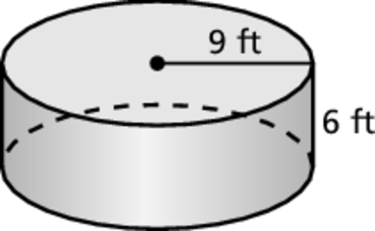

Find the surface area of the cylinder. Round your answer to the nearest tenth.
3. | 4.  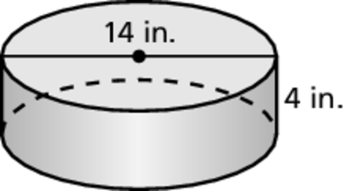

CRITICAL THINKING PROBLEMS
Problem 1: Cat food  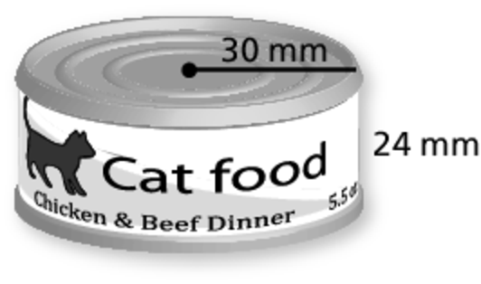 | - How much paper is used in the label for the can of cat food?  Round your answer to the nearest whole number. ________________  - If the company is making the label and it cost them $0.05 per mm², how much is each label? _____________
Problem 2: Cheese | The cut wedge represents one-eighth of the cheese.  - Find the surface area of the cheese before it is cut. ________________  - Find the surface area of the remaining cheese after the wedge is removed. Did the surface area increase, decrease, or remain the same? ________________
https://static.bigideasmath.com/protected/content/pe/ca/g7_09.pdf

