Name: _______________ Table #: ______ Period: _______ Date: ______
9.3B Two Way Tables_Classwork
Objective: Construct and interpret a two-way table. Use relative frequencies and their percents calculated for rows and columns to describe possible association between the two variables. Use ratios to fill in missing data on two-way frequency tables. CCSS: 8.SP.4 HW: (9.3A) p. 390 #3 – 13 all
WARM UP: Remember that $72\%= \frac{72}{100}$ .
To find a percent without a denominator of 100:
- Convert the fraction to a denominator of 100 using a multiplicative relationship
EXAMPLE: $\frac{3}{5}$ would be $\frac{3 ∙20}{5 ∙20}= \frac{60}{100}=60\%$
- Divide the numerator by the denominator and then multiply by 100
EXAMPLE: $\frac{3}{5}$ would be $3 ÷5= .6, then .6 ∙100=60 or 60\%$

FOR THE FRACTIONS BELOW, CONVERT EACH ONE INTO A PERCENT. SHOW HOW YOU GOT YOUR ANSWER. IF NECESSARY, ROUND TO THE NEAREST TENTH.
- $\frac{1}{25}$ | - $\frac{6}{20}$ | - $\frac{3}{8}$ | - $\frac{2}{3}$

`
- You randomly survey students in a school about whether to buy a lunch or pack a lunch.

- Make a two-way table that includes the marginal frequencies.
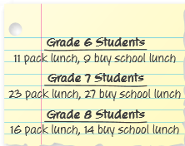
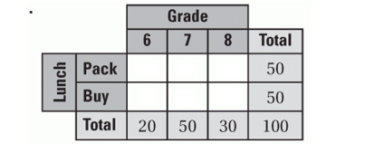

- For each grade level, what percent of the students in the survey pack a lunch? Buy a school lunch? Organize the results in a two-way table. Explain what one of the entries represents.

- Does the table in part (b) show a relationship between grade level and lunch choice? Explain.

- You randomly survey in 6th, 7th, and 8th grade about whether they are going to try to join student council. The results are shown in the tally sheets.
- Make a two way table that includes the marignal frequencies. HINT:Use the tally sheets to calculate each joint frequency. Then add to find each marginal frequency.
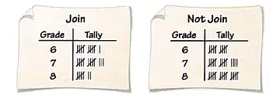 | GRADE  Join 6th 7th 8th TOTAL  the Yes  council No  TOTAL

- For each grade, what percent of the students in the survey are going to try to join student council? Not try to join student council? Organize the results in a two-way table. Explain what one of the entries represents.
 |  |  | GRADE
Join |  | 6th | 7th | 8th
the | Yes
council | No

- Does the table in part (b) show a relationship between grade and whether students are going to try to join student council? Explain.

EXAMPLE
Mary surveys 7th grade and 8th grade students whether they like or don’t like to play soccer. She discovers that the ratio of the number of students who like to play soccer to those who don’t like to play score is 3:4. Complete the two-way table with the results of the survey.
 | Like to Play | Do Not Like to
 | Soccer | Play Soccer
7th Grade | 38 | 55
8th Grade | 37 | x

- A student surveys households asking whether there are children in the household and whether there are pets in the household. The student discovers that the ratio of the number of households with pets to those with no pets is 3:5. Complete the two-way table with the results of the survey.

 | Pet | No Pet
Children | 40 | X
No Children | 50 | 70

https://www.youtube.com/watch?v=k8xFH6fCIWs & https://www.youtube.com/watch?v=1yKJigdwClU
Name: ___________________________________________ Per ___ Table# ____ Date __________
Practice Test Review (Chapter 9)

(TEST PROBLEM #15) Every student in two different classes is asked whether they like basketball and whether they like bowling. The results of the survey for each class are shown in the two-way tables. Determine whether each statement below refers to Class 1 or to Class 2.

Class 1 | Like Basketball | Do Not Like Basketball
Like Bowling | 10 | 4
Do Not Like Bowling | 15 | 7

Class 2 | Like Basketball | Do Not Like  Basketball
Like Bowling | 12 | 8
Do Not Like Bowling | 10 | 2

Class 1 | Class 2

- Fourteen students in the class like bowling
- 60% of students who like bowling also like basketball
- 40% of students who like basketball also like bowling
- Ten students in the class do not like basketball

