Name: __________________ Table #: _____ Period: ______ Date: _____
9.4 Choosing a Data Display_Classwork

Objective: choose appropriate data displays; identify and analyze misleading data displays. Applying Standard 8.SP.1
HW: (9.4) p. 397 #4 – 14 (Remember to “explain your reasoning”)

 | What does it do? | (pg 394)
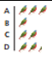 | Shows data using pictures
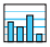 | Shows data in specific categories
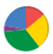 | Shows data as parts of a whole (out of 100%)
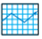 | Show how data change over time
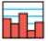 | Shows frequencies of data values in intervals of the same size
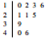 | Orders numerical data and shows how they are distributed
 | Shows the variability of a data set by using quartiles
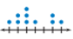 | Shows the number of times each value occurs in a data set
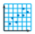 | Shows the relationship between two data sets by using ordered pairs in a coordinate plane

Read Example 1 (p. 394) and do On Your Own #1 & 2
Choose an appropriate data display for the situation. Explain your reasoning.

- The population of the United States divided into age groups.

- The percents of students in your school who play basketball, football, soccer, or lacrosse.

- #15 (textbook)_A nutritionist wants to use a data display to show the favorite vegetables of the students at a school. Choose an appropriate data display for the situation.

Read Example 2 (p. 395) and do On Your Own #3-5  You record the number of hits for your school’s new website for 5 months. Tell whether the data display is appropriate for representing how the number of hits changed during the 5 months. Explain your reasoning.  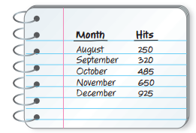 | Tell whether the data display is appropriate for representing the data in Example 2. Explain your reasoning.  - Dot plot:  - Circle graph:  - Stem-and-leaf plot:

Read Example 3 & 4 (p. 396) and do On Your Own #6 & 7 Explain why the data display is misleading
6. | 7.

PRACTICE PROBLEMS
#16 (textbook)_A scientist gathers data about a decaying chemical compound. The results are shown in the scatter plot. Is the data display misleading? Explain.  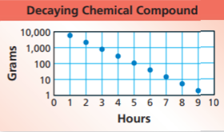 | #18 (textbook)_A survey asked 100 students to choose their favorite sports. The results are shown in the circle graph. 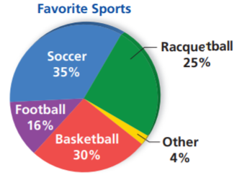  - Explain why the graph is misleading.  - What type of data display would be more appropriate for the data? Explain.
Examples of Data Displays

STEM AND LEAF PLOT:
Ages of Teachers
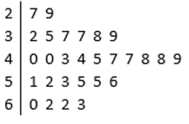

HISTOGRAM
Ages of Teachers
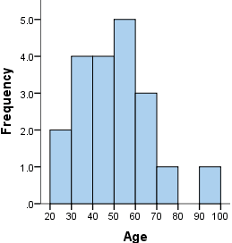

BOX AND WHISKER PLOT
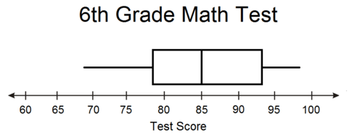

https://static.bigideasmath.com/protected/content/pe/ca/g8_09.pdf

