Name: \_\_\_\_\_\_\_\_\_\_\_\_\_\_\_\_\_\_\_\_\_ Table #: \_\_\_\_\_ Period: \_\_\_\_ Date: \_\_\_\_\_\_

**9.5A Volumes of Pyramids \_Classwork**

*Objective: find volumes of pyramids. CC.SS.7.G.6*

*HW: 9.5A pg 386\_#4-11 ALL*

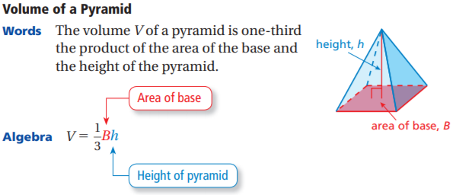

Find the volume of the pyramid.

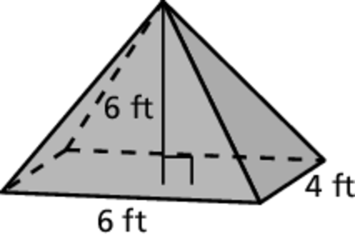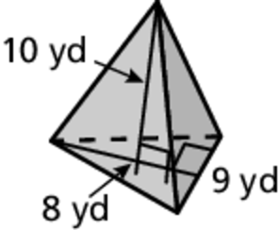 1. 2.

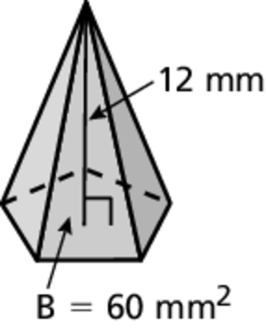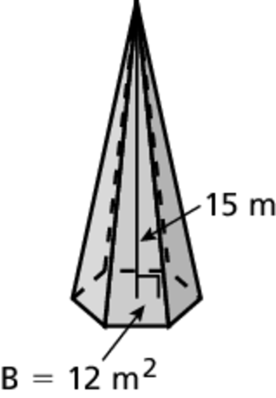 3. 4.

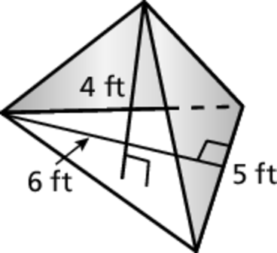 5. You create a simple tent in the shape of a pyramid.  
What is the volume of the tent?

**Cross Sectionals of Three-Dimensional Figures**

Describe the intersection of the plane and the solid.

|  |  |  |  |
| --- | --- | --- | --- |
| 1.  TA: S:\mscc7wb03.01\Red Production\Red Record and Practice Journal\Art\09\mscc7_rpj_0905_18.eps,11/7/2012 1:23:27 PM replaced: 7/31/2016 7:32:51 PM | 2.  TA: S:\mscc7wb03.01\Red Production\Red Record and Practice Journal\Art\09\mscc7_rpj_0905_19.eps,11/7/2012 1:23:51 PM replaced: 7/31/2016 7:32:52 PM | 3.  TA: S:\mscc7wb03.01\Red Production\Red Record and Practice Journal\Art\09\mscc7_rpj_0905_20.eps,11/7/2012 1:24:17 PM replaced: 7/31/2016 7:32:53 PM | 4.  TA: S:\mscc7wb03.01\Red Production\Red Record and Practice Journal\Art\09\mscc7_rpj_0905_21.eps,11/7/2012 2:26:50 PM replaced: 7/31/2016 7:32:53 PM |
| 5.  TA: S:\mscc7wb03.01\Red Production\Red Record and Practice Journal\Art\09\mscc7_rpj_0905_22.eps,11/7/2012 2:06:15 PM replaced: 7/31/2016 7:32:55 PM | TA: S:\mscc7wb03.01\Red Production\Red Record and Practice Journal\Art\09\mscc7_rpj_0905_23.eps,11/7/2012 2:04:57 PM replaced: 7/31/2016 7:32:56 PM6. | 7.  TA: S:\mscc7wb03.01\Red Production\Red Record and Practice Journal\Art\09\mscc7_rpj_0905_24.eps,11/7/2012 2:41:21 PM replaced: 7/31/2016 7:32:56 PM | 8.TA: S:\mscc7wb03.01\Red Production\Red Record and Practice Journal\Art\09\mscc7_rpj_0905_25.eps,11/7/2012 2:41:36 PM replaced: 7/31/2016 7:32:57 PM |
| 9.  TA: S:\mscc7wb03.01\Red Production\Red Record and Practice Journal\Art\09\mscc7_rpj_0905_26.eps,11/7/2012 2:40:57 PM replaced: 7/31/2016 7:32:58 PM | 10.  TA: S:\mscc7wb03.01\Red Production\Red Record and Practice Journal\Art\09\mscc7_rpj_0905_27.eps,11/7/2012 2:41:51 PM replaced: 7/31/2016 7:32:59 PM | 11.  TA: S:\mscc7wb03.01\Red Production\Red Record and Practice Journal\Art\09\mscc7_rpj_0905_28.eps,11/7/2012 4:12:07 PM replaced: 7/31/2016 7:32:51 PM | 12.  TA: S:\mscc7wb03.01\Red Production\Red Record and Practice Journal\Art\09\mscc7_rpj_0905_29.eps,11/7/2012 4:19:49 PM replaced: 7/31/2016 7:33:00 PM |