Name: ___________________________________________ Per ___ Table# ____ Date __________
Group Members: ____________________________________________________________________
GROUP TEST – Chapter 9. Make sure EVERY group member has the exact same answers. One or two papers will be graded at random and the group will receive the grade of the test(s) graded, regardless of what is on another person’s test. Remember to also SHOW ALL WORK.

- What is the relationship between the amount of rainfall and the duration of time it rains?
- Draw a scatter plot and a line of best fit for the data set below. Label the axes.
PICK (6, 8) and (10, 13) to write the equation.
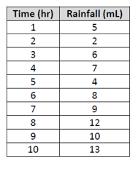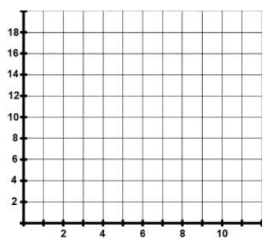

- Equation for line of best fit ______________________________

- Use your equation for the line of best fit (LOBF) to determine the amount of rainfall at 6.5 hours.

- Use your equation for LOBF to determine the number of hours it takes to have 14 mL of rain fall.

- The scatter plot show the number of sports utility vehicles sold in a city from 2009 to 2014.
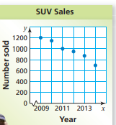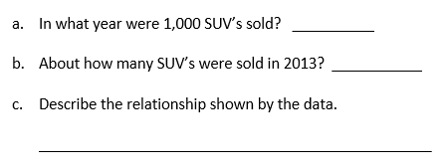

- A student surveys households asking whether there are children in the household and whether there are pets in the household. The student discovers that the ratio of the number of households with pets to those with no pets is 4:5. Complete the two-way table with the results of the survey.
 | Pet | No Pet
Children | 20 | X
No Children | 32 | 30

- The two-way table shows the people of the age of 18 and under who own a dog. Answer the following questions below.
 | Have a dog | Don’t have a dog
Ages 4 - 8 | 120 | 180
Ages 9 - 13 | 230 | 170
Ages 14 - 18 | 340 | 150

- For the “Age 4-8”, what is the percent that have a dog? _____________________________

- What is the marginal frequency for “Ages 14-18?” __________________________________

- For the “Age 9-13”, what is the percent that don’t have a dog? _______________________

- Choose an appropriate data display for the situation. Explain your reasoning.
- The price of a stock over the last 5 years.

- The heights of girls in grade 6 through 12.

- The percentages of income budgeted for food, utilities, housing, gas, and education.

