Name: _______________________ Table #: _____ Period: __________ Date: ______
Areas and Circumferences of Circles_Classwork
Objective: find area of semicircles
CC.SS.7.G.4_MP4 Model with Mathematics

SEMICIRCLE
To find the area of a semicircle you: ___________________________________________________________________________________

- The area of the orchestra pit is one-half the area of a circle with a diameter of 30 feet. Find the area of the orchestra. Round answer to the nearest tenth and use 3.14 for pi.  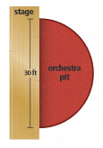 | - Find the area of the semicircular region. Round answer to the nearest tenth and use 3.14 for pi.  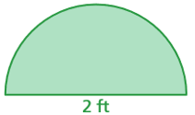
- Find the area of the semicircular region. Round answer to the nearest tenth and use 3.14 for pi.  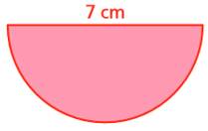 | - Find the area of the semicircular region. Round answer to the nearest tenth and use 3.14 for pi.  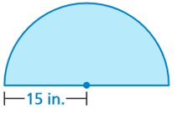

SEMICIRCLE
To find the perimeter of a semicircular region you __________________________________________________________________________________

- Find the perimeter of the semicircular region. Round answer to the nearest tenth and use 3.14 for pi.  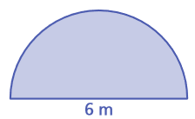 | - Find the perimeter of the semicircular region. Round answer to the nearest tenth and use 3.14 for pi.
- Find the perimeter of the semicircular region. Round answer to the nearest tenth and use 3.14 for pi. | - Find the perimeter of the semicircular region. Round answer to the nearest tenth and use 3.14 for pi.
Perimeters of Composite Figures_Classwork
Objective: find perimeters of composite shapes. CC.SS.7.G.4.
DIRECTION: Round answer to the nearest tenth and use 3.14 for pi.

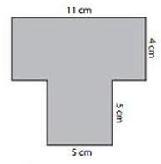
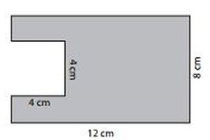
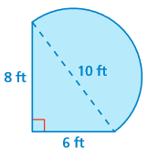
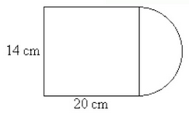

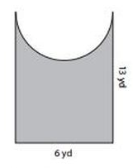
Name: ___________________________ Table #: ______ Period: ______ Date: _____
Area and Perimeter of Composite Figures

Objective: find areas of composite figures by separating them into familiar figures.
CC.SS.7.G.6_MP1 Make Sense of Problems of Persevere in Solving Them

Complete the following questions using your knowledge of composite shapes. Break the composite figures into simpler shapes and calculate the area and perimeter.

- Find the area and perimeter of the swimming pool.

PERIMETER: __________________ AREA: ________________________

- Find the area and perimeter of the running track. Use 3.14 for $π.$

PERIMETER: __________________ AREA: ________________________

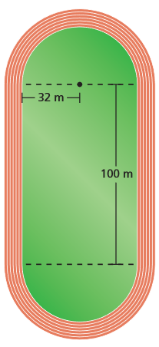

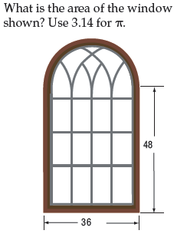
- What is the area and perimeter of the window shown? Use 3.14 for $π.$

PERIMETER: __________________ AREA: ____________________

- The diagram at the right gives the dimensions of a swimming pool. If a cover is needed for the pool, what will be the approximate area of the cover? How many feet of metals do you need to buy to have the fence around the pool?

PERIMETER: __________________ AREA: ________________________

