Name: _______________________ Table #: _____ Period: __________ Date: ______
Areas of Composite Figures_Classwork
Objective: find areas of composite figures by separating them into familiar figures.
CC.SS.7.G.6_MP1 Make Sense of Problems of Persevere in Solving Them

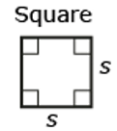  Area = |  | 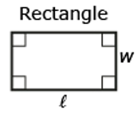  Area = |  | 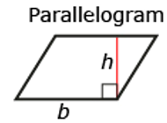  Area = |  | Right Triangle  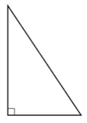  Area =
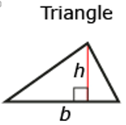  Area = |  | 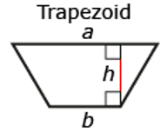  Area = |  | 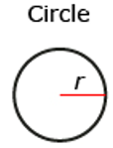  Area = |  | Semicircle  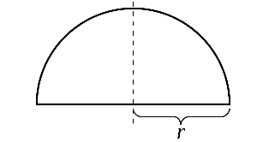  Area =
Composite Figure  A composite figure is |  |  |  | 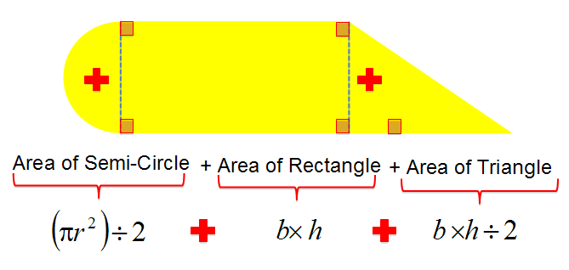
 | Composite Figures |  | Draw the composite figure into smaller BASIC FIGURES. |  | Find the area of each BASIC FIGURE. |  | Add the area of all of the figures
 | 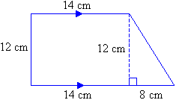
 | 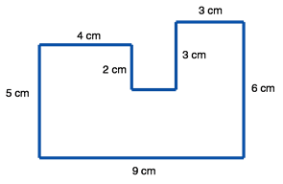
 | 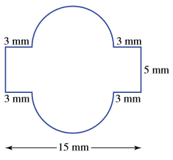
Name: _______________________ Table #: _____ Period: __________ Date: ______
Areas of Composite Figures_Classwork
Objective: find areas of composite figures by separating them into familiar figures.
CC.SS.7.G.6_MP1 Make Sense of Problems of Persevere in Solving Them
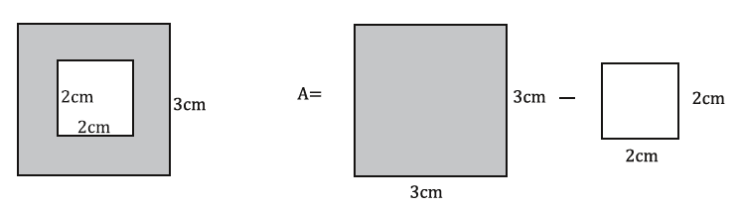
Composite Figures | Draw the BIG figure and the unwanted figure(s) | Find the area of each BASIC FIGURE. | Subtract the whole Basic Shape from the unwanted shape
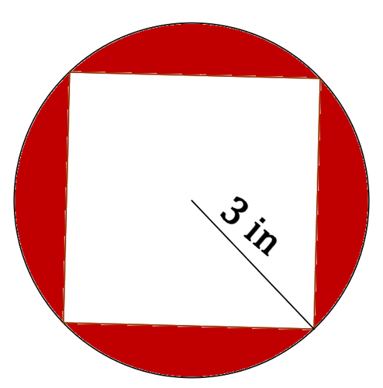
4.5 in
Composite Figures | Draw the BIG figure and the unwanted figure(s) | Find the area of each BASIC FIGURE. | Subtract the whole Basic Shape from the unwanted shape
