Name: _________________________________________ Table# ___ Period _____ Date _________

Group Members: ___________________________________________________________________
CC Math 8_ CHAPTER 7 GROUP TEST
EVERY GROUP MEMBER NEEDS TO SHOW WORK FOR EVERY PROBLEM. PLEASE CIRCLE ANSWERS. BE SURE TO INCLUDE UNITS OF MEASURE WHERE APPROPRIATE.
- Find the value of x. Round your answer to the nearest hundredth.
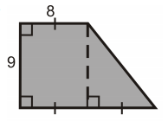
X
- Which of the following expressions are greater than 10 and less than 15? CIRCLE ALL THAT APPLY.
i. $\sqrt{101}$ ii. $\sqrt{12}$ iii. $\sqrt{85}$ iv. $\sqrt{200}$ v. $\sqrt{144}$ vi. $\sqrt{15}$

- Which of the following are irrational? CIRCLE ALL THAT APPLY.
i. $\sqrt{36}$ ii. $\sqrt{37}$ iii. $\sqrt{25}$ iv. $\sqrt{24}$ v. $\sqrt{3}$ vi. $\sqrt{4}$
- Find the distance between the points (4, -5) and (-1, 7).

- A right triangle has a leg measuring 24 units. Which of these statements is correct? Select two that apply. (Show your work for full credit)
- If the length of the hypotenuse is 25 units, the length of the other leg is 7 units.
- If the length of the hypotenuse is 26 units, the length of the other leg is 12 units.
- If the length of the hypotenuse is 28 units, the length of the other leg is 14 units.
- If the length of the hypotenuse is 30 units, the length of the other leg is 18 units.

CONTINUED ON BACK $→→→→→→→→→$
- The volume of a cube-shaped shipping container is 4096 cubic centimeters. Find the edge length of the shipping container.

- Use the figure below to answer questions a – d. Round your answers to the nearest tenth.
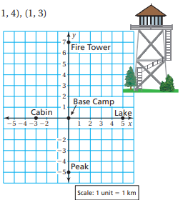
- How far is the cabin from the peak?

- How far is the fire tower from the lake?

- How far is the lake from the peak?

- You are standing at (-5, -6). How far are you from the lake?

