Name: ________________________ Table #: _______ Period: ______
Chapter 13 Composite Figures Project
CC.SS. 7.G.4 Know the formulas for the area and circumference of a circle and use them to solve problems
CC.SS.7.G.6 Solve real-world and mathematical problems involving area two-dimensional objects composed of triangles, quadrilaterals, and polygons

DUE: Thursday, 11/7/2019
You will use graph paper to create ONE complex composite figure. The complex composite figure must have at least 4 different basic shapes, but you can have more.
Basic shapes include: square, rectangle, circle, semicircle, triangle, right triangle, trapezoid, and parallelogram. You can use worksheet 13.4A NOTES for the formula.
NOTE: Each square on the graph paper will be 1 inch.

Requirement | Points
The composite figure is complex and is creative | 5 points
The composite figure has at LEAST 4 different basic shapes. Example: 4 different rectangles put together is not consider 4 different shapes. | 5 points
The work for finding the area of the composite figure is clear and correct | 10 points
Colorful and all lines are straight.  Include a title of the composite figure. | 5 points
Extra credit: the composite figure has at least 6 basic shapes or more | 2 points
Extra credit: the composite figure is being created on the computer and print it out | 2 points
TOTAL: | ______/25 pts

EXAMPLE: The Blue Car
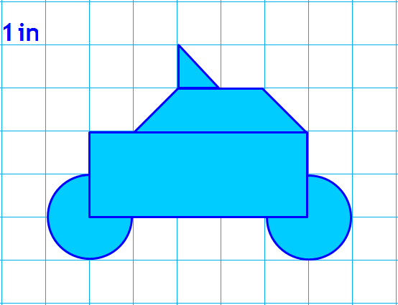
http://www.mathwire.com/templates/graphpaperhalfinch.pdf
NAME: _________________________ PERIOD: ________

TITLE: ___________________________________________

