Name: _________________________________________ Table# ___ Period _____ Date _________

**15.1 Outcomes and Events_Classwork**

*Objective: Students will be able to construct viable arguments and critique the reasoning of others MP3.*

*CC.SS.7.SP.5 identify and count the outcomes of experiments.*

|  |  |  |  |
| --- | --- | --- | --- |
| **WARM-UP**   |  |  |  | | --- | --- | --- | | 1. Evaluate: | 1. Evaluate: *1* | 1. What makes a game fair? | |

**Rock Paper Scissors Experiment**

|  |
| --- |
| 1. How many possible results (outcomes) are there? Explain your reasoning. 2. Play Rock Paper Scissors 20 times. Tally your results in the table. 3. Of the possible results, in how many ways can:   Player A win? Player B win? The players tie?   1. Does one of the players have a better chance of winning than the other player? Explaining your reasoning. 2. Is this a fair game? |

|  |
| --- |
| **Experiment:** |
| **Possible Outcomes:** |
| **Event:** |
| **Favorable Outcomes:** |

EXAMPLE PROBLEMS

1. A bag is filled with 4 red marbles, 3 blue marbles, 3 yellow marbles, and 2 green marbles. You randomly choose one marble from the bag. (a) Find the number of ways the event can occur. (b) Find the favorable outcomes of the event.

1. Choosing red 2. Choosing green

3. Choosing yellow 4. Choosing *not* blue

5. In order to figure out who will go first in a game, your friend asks you to pick a number between 1 and 25.

a. What are the possible outcomes?

b. What are the favorable outcomes of choosing an even number?

c. What are the favorable outcomes of choosing a number less than 20?

+++++++++++++++++++++++++++++++++++++++++++++++++++++++++++++++++++++++++++++++++++++++++++++

1. LETTERS. You randomly choose a letter from a hat that contains the letters A through K.
2. What are the possible outcomes?
3. What are the favorable outcomes of choosing a vowel?

Name: ________________________________ Table #: ________ Period: __________ Date: ________

**15.2 Probability_Classwork**

*Objective: Attend to Precision MP3. CCSS.7.SP.5 and CCSS.7.SP.7a understand the concept of probability and the relationship between probability and likelihood; find probabilities of events.*

*HW: textbook- pg 642_#1-15 ALL (write down each problem and show work)*

|  |
| --- |
| Probability is: |
| Probabilities are written as:   * _______________________________________________________________________________________ * _______________________________________________________________________________________ * _______________________________________________________________________________________ |
| * If an event is CERTAIN to happen, then ________________________________________________________ * If an event will NEVER to happen, then ________________________________________________________ * If an event is just LIKELY to happen as to not happen, then ________________________________________ |
| Diagram: |
| 1. List 2 events that will never happen and have a probability of 0 %. 2. List 2 events that are certain to happen and have a probability of 100% 3. List 2 events that have equal chances of happening and have a probability of 50% |
| The probability of an event is written: |
| * An **outcome** is * An **event** is |

**PRACTICE PROBLEMS**

Describe the likelihood of the event given its probability.

1. There is a 30% chance of snow tomorrow.

2. You solve a brain teaser 0.75 of the time.

You randomly choose one hat from 3 green hats, 4 black hats, 2 white hats,   
2 red hats, and 1 blue hat. Find the probability of the event.

3. Choosing a red hat 4. Choosing a black hat

5. *Not* choosing a white hat 6. Choosing a blue hat

7. *Not* choosing a black hat 8. *Not* choosing a green hat

9. The probability that you draw a mechanical pencil from a group of   
25 mechanical and wooden pencils is  How many are mechanical pencils?

Name: ___________________________Table# ____ Period _____ Date ___________

**15.3A Theoretical Vs Experimental Probability_Classwork**

*Objective: Attend to Precision (MP6). Use experimental probabilities to make predictions; use theoretical probabilities to find quantities; compare experimental and theoretical. CCSS.7.SP.5, CCSS.7.SP.6, and CCSS.7.SP.7*

*HW: 15.3A worksheet*

|  |
| --- |
| **What do you know about probability?** |
| **Contrast experimental and theoretical probability**   |  |  | | --- | --- | | Experimental Probability | Theoretical Probability: | |
| **Example 1**   |  |  | | --- | --- | | Experimental Probability | Theoretical Probability: | |
| **Experimental vs Theoretical**  Theoretical Probability:  Experimental probability: |

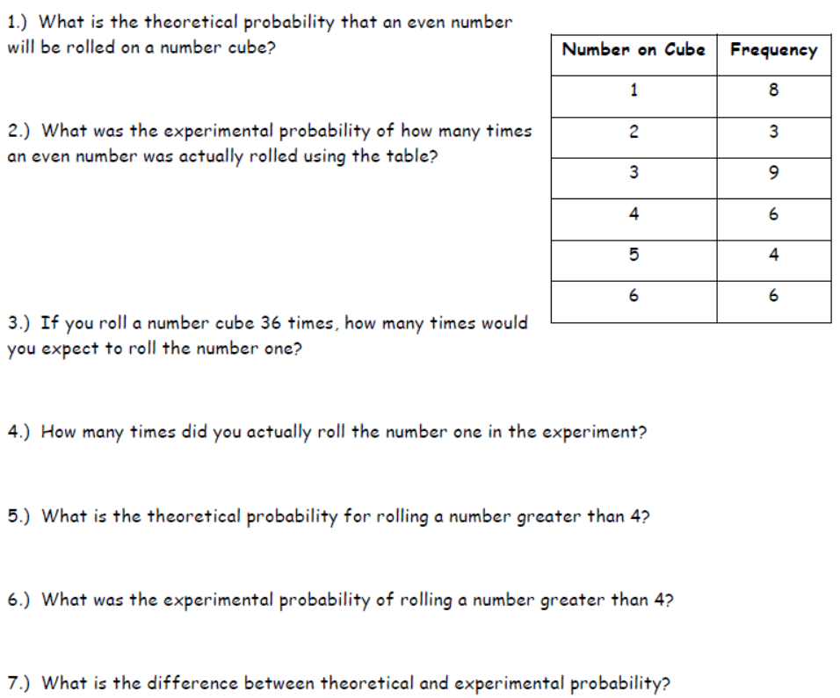

1) 1/2 2) 4/9 3) 6 4) 8 5) 1/3 6) 5/18 7) theo= what should happened; exp= what actually happens

Name Date

15.3A HOMEWORK

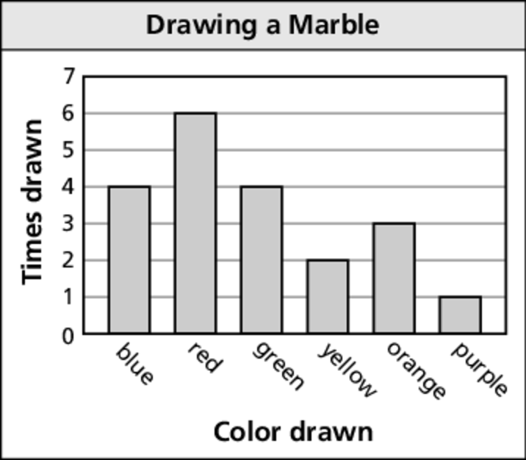Use the bar graph to find the experimental probability   
of the event.

1. Drawing red 2. Drawing orange

3. Drawing *not* yellow 4. Drawing a color with more than 4 letters in its name

5. There are 25 students’ names in a hat. You choose 5 names. Three are boys’ names and two are girls’ names. How many of the 25 names would you expect to be boys’ names?

Use a number cube to determine the theoretical probability of the event.

6. Rolling a 2 7. Rolling a 5

8. Rolling an even number 9. Rolling a number greater than 1

Name: ___________________________Table# ____ Period _____ Date ___________

**15.3B Theoretical Vs Experimental Probability_Classwork**

*Objective: Attend to Precision (MP6). Use experimental probabilities to make predictions; use theoretical probabilities to find quantities; compare experimental and theoretical. CCSS.7.SP.5, CCSS.7.SP.6, and CCSS.7.SP.7*

*HW: textbook 15.3B pg 649_ #6-23 ALL*

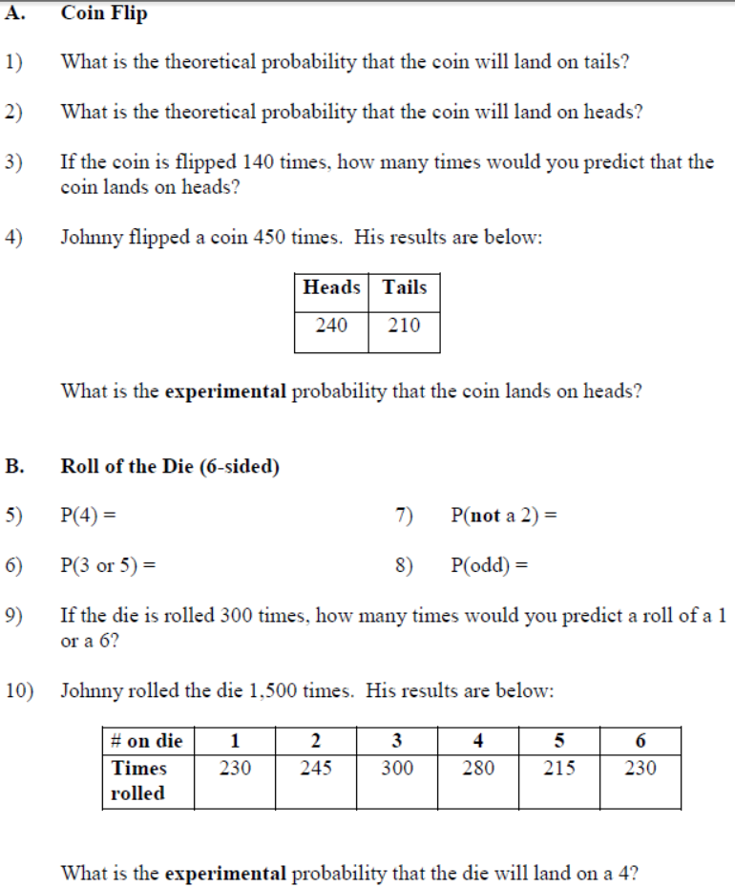

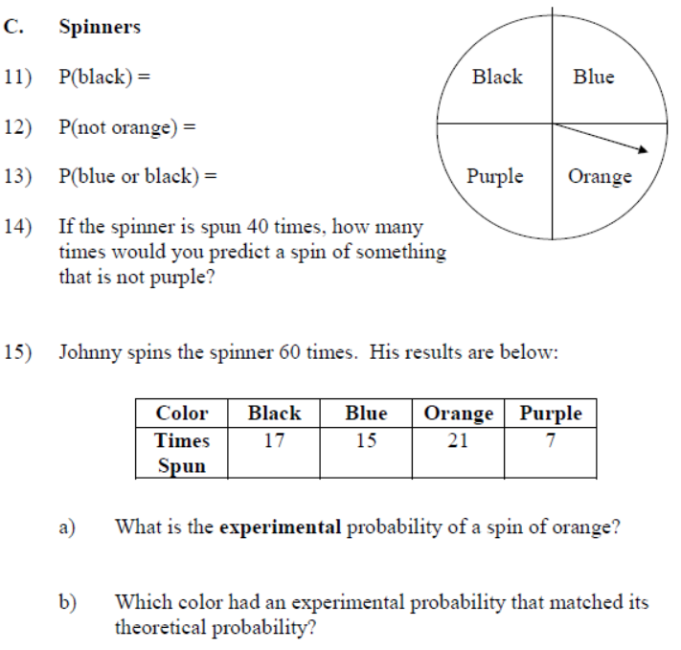

+++++++++++++++++++++++++++++++++++++++++++++++++++++++++++++++++++++++++++++++++++++++++++++

**CHALLENGING PROBLEMS (pg 650 in textbook)**

1. GAME SHOW. On a game show, a contestant randomly chooses a chip form a bag that contains numbers and strikes. The theoretical probability of choosing a strike is 3/10. The bag contains 9 strikes. How many chips are in the bag?
2. MUSIC. The theoretical probability that a pop song plays on your MP3 player is 0.45. There are 80 songs on your MP3 player. How many of the songs are pop songs?
3. MODELING. There are 16 females and 20 males in a class.
   1. What is the theoretical probability that a randomly chosen student is female?
   2. One week later, there are 45 students in the class. The theoretical probability that a randomly chosen student is a female is the same as last week. How many males joined the class?

Name: ____________________________ Table #:_______ Period: ____________ Date: ________

**15.4A Fundamental Counting Principle_Classwork**

*Objective: Model with Mathematics (MP3). Use tree diagrams, tables, or a formula to find the number of possible outcomes; find probabilities of compound events (CCSS.7.SP.8)*

*HW: textbook 15.4B pg 657_#8-24 ALL*

|  |  |
| --- | --- |
| **Fundamental counting principle:** | |
| **Example 1:** You flip a coin and spin the spinner with 3 equal sizes. How many outcomes are possible? | **Example 2:** You pick a marble (a bag of 4 marbles) and roll a die. How many outcomes are possible? |
| **Compound Event:** | |
| **Example 1:** You flip a coin and spin the spinner with 3 equal sizes (A, B, and C). What is the probabilities of getting an A/Head? | **Example 2:** You pick a marble (a bag of 4 marbles: Red, Yellow, Green, Blue) and roll a die. What is the probabilities of getting a Red/even number? |
| **Example 3:**   1. Find the total number of possible outcomes of rolling a number cube and flipping a coin. 2. What is the probability of rolling a number greater than 4 and flipping tails? | **Example 4:**  You flip three nickels. What is the probability of flipping two head and one tails? |

Name Date

**Practice problems**

1. Use a tree diagram to find the total number of possible outcomes.

|  |  |
| --- | --- |
| Bed Sheets | |
| Size | Twin, Twin XL, Full, Queen, King |
| Style | Solid, Patterned |

Use the Fundamental Counting Principle to find the total number of possible outcomes.

2. 3.

|  |  |
| --- | --- |
| Photos | |
| Size | Wallet, 4 by 6, 5 by 7,  8 by 10, 11 by 14, 16 by 20 |
| Finish | Matte, Glossy |
| Edits | Red eye, Black and white, Crop |

|  |  |
| --- | --- |
| Laptops | |
| Hard Drive | 250 GB, 320 GB, 500 GB |
| Style | HD, LCD |
| Color | Black, White, Red, Blue, Pink, Green, Purple |

You spin the spinner and flip a coin. Find the probability of the events.

4. Spinning a 2 and flipping tails

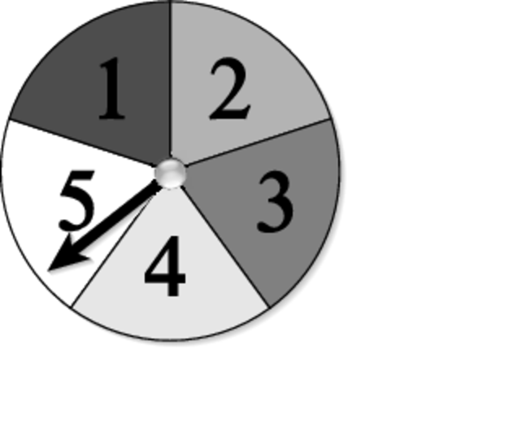

5. Spinning a 7 and flipping heads

6. *Not* spinning a 4 and flipping tails

Name: ___________________________________ Table# _______ Period _____ Date _____________

**15.4B “Which Lock is Better?”_Classwork**

*Objective: Model with Mathematics (MP3). Use tree diagrams, tables, or a formula to find the number of possible outcomes; find probabilities of compound events (CCSS.7.SP.8)*

|  |
| --- |
| Question:  You are buying a combination lock. You have three choices:   1. **Lock** **1** has 3 wheels. Each wheel is numbered from 0 to 9. 2. **Lock 2** has numbered from 0 to 39. Each combination uses 3 numbers. 3. **Lock 3** has 4 wheels. Wheel 1: 0 to 9, Wheel 2: A to J, Wheel 3: K to T, and Wheel 4: 0 to 9     Lock 1 Lock 2 Lock 3 |
| **CLAIM** (Which lock would you get?) |
| **EVIDENCE** (What work did you do to solve this problem?)   |  |  |  | | --- | --- | --- | | **Lock 1** | **Lock 2** | **Lock 3** | |  |  |  | |
| **REASONING** (Summarize in two to three sentences how you know you are correct.) |

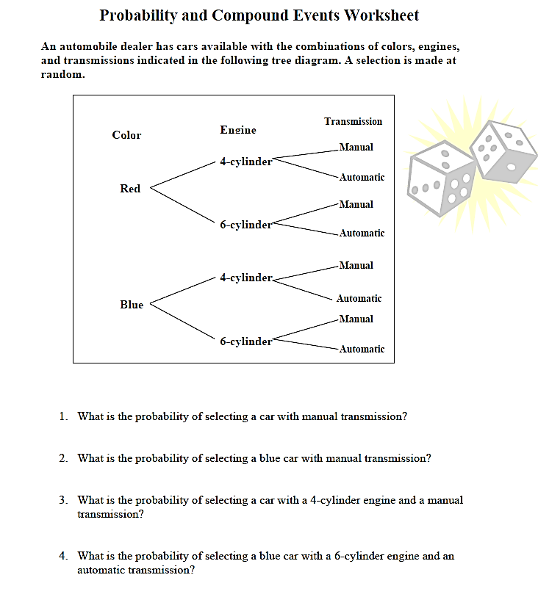

Name: __________________________ Table #’: ___________ Period: ____________ Date: _____

**15.5A Independent and Dependent Events_Classwork**

*Objective: identify independent and dependent events; use formulas to find probabilities of independent and dependent events (CC.SS.7.SP.8a and CC.SS.7.SP.8b. MP3 Construct Viable Arguments)*

*HW: textbook- BIM pg 665_#3-13 ALL*

|  |
| --- |
| **Independent Events**  Whatever happens in one event has absolutely nothing to do with what will happen next because:  1) The two events are _________________________________________________________________________  2) You repeat the experiment __________________________________________________________________  3) You repeat the same activity, but you __________________________________________________________ |
| **Dependent Event**  The result of the second event (pick) will change because ____________________________________________ |
| **Are these dependent or independent events?**   1. Tossing two dice and getting a 6 on both of them.   ___________________ because __________________________________________________________   1. You have a bag of marbles: 3 blue, 5 white, and 12 red. You choose one marble out the bag, look at it then put it back. Then you choose another marble.   ___________________ because __________________________________________________________   1. You have a basket of socks. You need to find the probability of pulling out a black sock and its matching black sock without putting the first sock back.   ___________________ because __________________________________________________________   1. You pick the letter Q from a bag containing all the letters of the alphabet. You do not put the Q back in the bag before you pick another tile.   ___________________ because __________________________________________________________ |
| **Rewrite each question as a probability notation.**   1. What is the probability of tossing two dice and getting a 6 on both of them? 2. You have a bag of marbles: 3 blue, 5 white, and 12 red. You choose one marble out the bag, look at it then put it back. Then you choose another marble. What is the probability of picking a red and white? 3. You have a basket of socks. You need to find the probability of pulling out a black sock and its matching black sock without putting the first sock back. 4. You pick the letter Q from a bag containing all the letters of the alphabet. You do not put the Q back in the bag before you pick another tile. What is the probability of getting a Q first and a T second? |

Watch the video and take notes: <https://www.youtube.com/watch?v=gNRT2KoyT7U>

|  |  |  |
| --- | --- | --- |
| **Problem 1:** Using the bag of marbles on the left, what is the probability of pulling a white marble two times in a row?  ______________________   |  |  | | --- | --- | | When you put 1st marble BACK IN  (Independent Events) | When you KEEP 1st marble  (dependent Events) | |
| **Problem 2**: Using the bag of marbles on the left, what is the probability of pulling a black marble two times in a row?  ______________________   |  |  | | --- | --- | | When you put 1st marble BACK IN  (Independent Events) | When you KEEP 1st marble  (dependent Events) | |
| **Problem 3**: Using the bag of marbles on the left, what is the probability of pulling black marble, and then a white marble?  ______________________   |  |  | | --- | --- | | When you put 1st marble BACK IN  (Independent Events) | When you KEEP 1st marble  (dependent Events) | |
| **Problem 4**: Using the bag of marbles on the left, what is the probability of pulling a white marble, then a striped marble?  ______________________   |  |  | | --- | --- | | When you put 1st marble BACK IN  (Independent Events) | When you KEEP 1st marble  (dependent Events) | |

Name: __________________________ Table #: ___________ Period: ____________ Date: _____

**15.5B Independent and Dependent Events_Classwork**

*Objective: identify independent and dependent events; use formulas to find probabilities of independent and dependent events (CC.SS.7.SP.8a and CC.SS.7.SP.8b. MP3 Construct Viable Arguments)*

*HW: 15.5B worksheet*

**Independent Events**: ___________________________________________________________________________

|  |  |
| --- | --- |
| 1. Bag A contains 9 red marbles and 3 green marbles. Bag B contains 9 black marbles and 6 orange marbles. Find the probability of selecting one green marble from bag A and one black marble from bag B. | 1. Two seniors, one from each government class are randomly selected to travel to Washington, D.C. Wes is in a class of 18 students and Maureen is in a class of 20 students. Find the probability that both Wes and Maureen will be selected. |

**Dependent Events:** _____________________________________________________________________________

|  |  |
| --- | --- |
| 1. A box contains 5 purple marbles, 3 green marbles and 2 orange marbles. Two consecutive draws are made from the box **without replacement** of the first draw. Find the probability of each event.   Without replacement means: ____________________  ____________________________________________   1. P(orange first, green second) 2. P(both marbles are purple) 3. P(the first marble is purple, and the second is ANY color EXCEPT purple) | 1. If there was only one government class, and Wes and Maureen were in that class of 38 students, what would be the probability that both Wes and Maureen would be selected as the two students to go to Washington?   Explain why the problem is an example of independent event? |

**PRACTICE PROBLEMS**

|  |  |
| --- | --- |
| 1. A six-sided die is rolled and a spinner with six equal spaces labeled A-F is spun 2. Independent event or dependent event? 3. How many possible outcomes are there? 4. P(1 and A) 5. P(odd and B) 6. P(1 and K) 7. P (prime and D) | 1. A card is drawn from the bag with number 1 through 10. Two consecutive draws are made from the bag without replacement of the first draw. 2. Independent event or dependent event? 3. How many possible outcomes are there? 4. P(3 and a 5) 5. P(even and a 1) 6. P(3 and less than 2) |
| 1. In a bag there are 2 red marbles, 3 white marbles and 5 blue marbles. Once a marble is selected, it is NOT replaced. Find the following probabilities. 2. Independent event or dependent event? 3. P(red, then white) 4. P(blue, then red) 5. P(red, red, red) 6. P(blue, blue, white) | 1. If you draw two cards from a standard deck of 52 cards without replacement, find: 2. Independent event or dependent event? 3. P(King first, Jack second) 4. P(face card first, ace second) 5. P(2 aces) |

Name: __________________________ Table #: ___________ Period: ____________ Date: _____

**15.5B HW**

*Objective: identify independent and dependent events; use formulas to find probabilities of independent and dependent events (CC.SS.7.SP.8a and CC.SS.7.SP.8b. MP3 Construct Viable Arguments)*

|  |  |
| --- | --- |
| 1. In a bag there are 2 red marbles, 3 white marbles and 5 blue marbles. Once a marble is selected, it is replaced. Find the following probabilities: 2. Independent event or dependent event? Explain.      1. P(white, blue) 2. P(white, white) 3. P(blue, white, red) 4. P(blue, blue, blue) | 1. A jar contains 4 white chips, 5 purple chips, and 1 black chip. Chips are selected randomly one at a time, and are not replaced. Find the probability of the following: 2. Independent event or dependent event? Explain. 3. P(purple, then black) 4. P(black then white) 5. P(white then purple) 6. P(2 whites) 7. P(2 purples) 8. P(2 blacks) 9. P(white, then purple, then black) 10. P(3 whites) |

BACK 🡪

Name Date

**15.5B HW**

You roll a number cube twice. Find the probability of the events.

1. Rolling a 3 twice 2. Rolling an even number and a 5

3. Rolling an odd number and a 2 or a 4 4. Rolling a number less than 6 and a 3 or a 1

You randomly choose a letter from a hat with the letters A through J. Without replacing the first letter, you choose a second letter. Find the probability of the events.

5. Choosing an H and then a D 6. Choosing a consonant and then an E or an I

7. Choosing a vowel and then an F 8. Choosing a vowel and then a consonant

9. You have 3 clasp bracelets, 4 watches, and 5 stretch bracelets. You randomly choose two from your jewelry box. What is the probability that you will choose 2 watches?

You flip a coin, and then roll a number cube twice. Find the probability of the event.

10. Flipping heads, rolling a 5, and rolling a 2

11. Flipping tails, rolling an odd number, and rolling a 4

12. Flipping tails, rolling a 6 or a 1, and rolling a 3

13. Flipping heads, *not* rolling a 2, and rolling an even number

Name Date

Answers

1. a.

b.

2. a.

b.

3. a.

b.

4.

5.

6.

7.

8.

9.

10.

11.

12.

13.

15.1-15.5 Review HW

Chapter

15

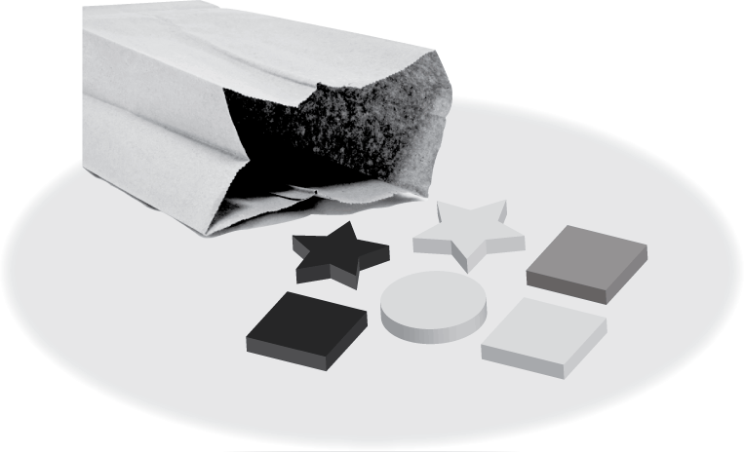You randomly choose one shape   
from the bag. (a) Find the number   
of ways the event can occur.   
(b) Find the favorable outcomes   
of the event.

1. Choosing a square

2. Choosing a circle

3. *Not* choosing a star

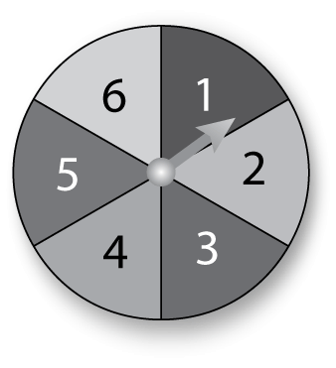

You spin the spinner once. Find the theoretical probability of the event.

4. Spinning a 5

5. Spinning an odd number

You throw two sticks 15 times and record the results. Use the table to find the experimental probability of the event.

|  |  |
| --- | --- |
| Outcome | Frequency |
| 2 blue | 4 |
| 2 pink | 3 |
| 1 blue, 1 pink | 8 |

6. Tossing 2 blue

7. Tossing 1 blue and 1 pink

8. *Not* tossing all blue

Use the Fundamental Counting Principle to find the total number of possible outcomes.

9. 10.

|  |  |
| --- | --- |
| Video Game | |
| Level | Beginner, Intermediate, Advanced |
| Character | Fish, Bird, Frog, Monkey, Horse |

|  |  |
| --- | --- |
| Vacation | |
| Location | Amusement Park, Historical Landmark, Beach, Mountains |
| Transportation | Plane, Car, Train |

11. You have 160 songs on your MP3 player. The probability of   
randomly choosing a rock song is 30%. How many of the songs   
on your MP3 player are *not* rock songs?

A game has a deck of cards with 10 red cards, 4 blue cards, and   
2 yellow cards. You randomly choose two cards. Find the probability   
of choosing the given cards.

12. two red cards 13. a blue card and a yellow card

Name Date

Answers

14.

15.

16.

17.

18.

19.

20.

**(continued)**

Chapter

15

You spin the spinner twice. Find the probability of the event.

14. Spinning a 3 then a 4

15. Spinning a 2 then a number greater than 2

16. Describe the likelihood of spinning an odd   
number then an even number.

17. Your bike lock has 4 digits numbered 0 to 9. Find the total number   
of possible combinations for the lock.

18. Your drawer contains 6 black socks and 8 white socks. You randomly choose two socks. What is the probability that both socks are black?

19. A bag contains 26 tiles with letters A through Z. Find the probability   
of drawing two vowels with replacement. Find the probability of drawing two vowels without replacement. Round your answers to   
the nearest thousandth. Which event is independent? Which event   
is dependent?

20. You roll a number cube and flip a coin. What is the probability of rolling a number less than 5 and flipping heads? Write your answer as a mixed number.

**ANSWERS**

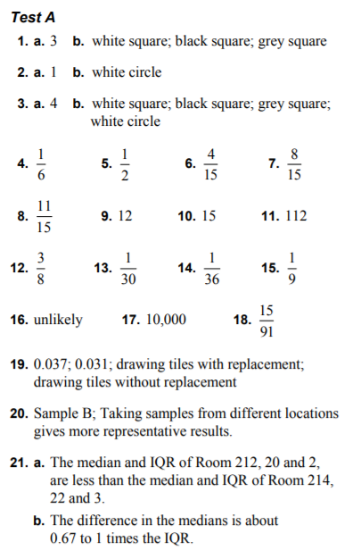

Name: ______________________ Table #:______ Period: ____ Date: _______

**15.6A Samples and Populations _Classwork**

*CC.SS.7.SP.1 and CC.SS.7.SP.2 _MP3 Construct Viable Arguments and Critique the Reasoning of Others*

*HW: 15.6A worksheet*

|  |  |  |  |
| --- | --- | --- | --- |
| **WARM-UP**  In a bag there are 2 red marbles, 3 white marbles and 5 blue marbles. Once a marble is selected, it is NOT replaced.   |  |  |  | | --- | --- | --- | | 1. Is this an independent or dependent event? How do you know? | 1. P(red, white) | 1. P(blue, blue, white) | |

|  |
| --- |
| **Population:**  **Sample:** |
|  |
| **Diagram** |
|  |
| **Which one is Sample and Population?**   1. Sample: ______________________________________________________________________________   Population: ____________________________________________________________________________   1. Sample: ______________________________________________________________________________   Population: ____________________________________________________________________________   1. Sample: ______________________________________________________________________________   Population: ____________________________________________________________________________   1. Sample: ______________________________________________________________________________   Population: ____________________________________________________________________________ |
| **Unbiased sample:**  **Biased Sample:** |
| **Example 1:** A 7th grade advisory was surveyed to determine how many texts students at Marston Middle School send each day.   * What is the population? * What is the sample? * Biased or unbiased? |
| **Example 2:** To track migration patterns of a particular species of bird, scientists randomly tag, release, and track 50 birds of that species.   * What is the population? * What is the sample? * Biased or unbiased? |
| **Example 3:** If you were taking a survey of the different colors of leaves seen in September, which of the following would be an unbiased sample? Choose the correct answer and explain why? |
| **Example 4:** You want to estimate the number of 7th grade students that walk home right after school in the spring time. Which sample is unbiased and explain why? |

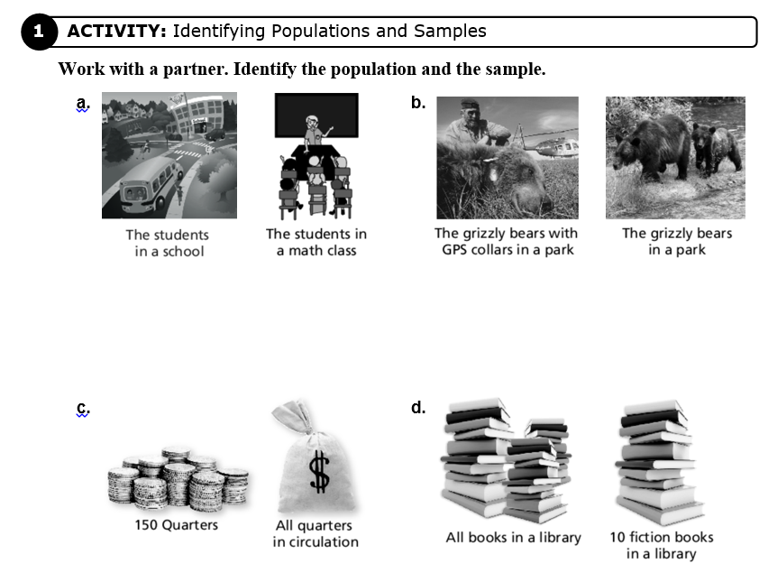

Name Date

15.6A Homework

Identify the population and the sample.

1. All students in a school 2. 75 strawberries in the field

30 students in the school All the strawberries in the field

3. You want to know the number of students in your school who read some of the newspaper at least once a week. You survey 30 random students that you meet in the hallway between classes.

a. What is the population of your survey?

b. What is the sample of your survey?

c. Is the sample biased or unbiased? Explain.

Which sample is better for making a prediction? Explain.

|  |  |
| --- | --- |
| Predict the number of residents in St. Lucie County who own a home. | |
| Sample A | A random sample of 100 residents in the county |
| Sample B | A random sample of 100 residents in the city of Fort Pierce |

4.

5.

|  |  |
| --- | --- |
| Predict the number of people at a beach who are wearing sunscreen. | |
| Sample A | A random sample of 50 people at the beach |
| Sample B | A random sample of 5 people at the beach |

BACK 🡪

Determine whether you would survey the population or a sample. Explain.

6. You want to know the average weight of the members of your family.

7. You want to know the number of grocery stores in Florida that carry your favorite cereal.

8. A survey asked 60 randomly chosen students if they eat school lunch. Forty said yes. There were 560 school lunches sold today. Predict the number of students who attend the school.

Name: ______________________ Table #:______ Period: ____ Date: _______

**15.6B Samples and Populations _Classwork**

*Objective: CC.SS.7.SP.1 and CC.SS.7.SP.2 _MP3 Construct Viable Arguments and Critique the Reasoning of Others*

*HW: CH 15 Practice Test on BIM*

|  |
| --- |
| **Random Sample:**  When a sample is selected at _______________, each member of the population is _______________________  _________________________. |
| *Example: You want to know the favorite extracurricular activity of students at your school. Determine whether each method will result in a random sample. Explain.*   1. You ask members of the school band. Random or not? 2. You publish a survey in the school newspaper. Random or not? 3. You ask every eight student who enters the school in the morning. Random or not? 4. You ask students in your class. Random or not? |
| **Representative Sample:** |
| **Inference:** |
| **Determining Whether Conclusions are Valid:**  *Example: You want to know how the residents of your town feel about adding a new stop sign. Determine whether each conclusion is valid.*   1. You survey the 20 residents who live closest to the new sign. Fifteen support the sign and five do not. So you conclude that 75% of the residents of your town support the new sign. 2. You survey 100 residents at random. Forty support the new sign, and sixty do not. So, you conclude that 40% of the residents of your town support the new sign. |

**BACK 🡪**

|  |
| --- |
| **Predicting Proportion:**  __________________ **=**  ___________________ |
| **Example 1:**  A university has 30,600 students. In a random sample of 240 students, 20 speak 3 or more languages. Predict the number of students at the university that speak 3 or more languages. |
| **Example 2:**  There are 4500 elk located on a preserve in Colorado. A biologist thinks that the herd may be infected with parasite. She does a random sample of 50 elk. If she discovers that 8 of the sample is infected. Predict how many elk the biologist can expect to be infected. |
| **Example 3:**  A factory produces 150,000 light bulbs per day. The manager estimates that less than 1,000 defective bulbs are produced each day. In a random sample of 250 light bulbs, there are 2 defective bulbs. Determine if the manager's estimate is likely to be accurate. Explain. |
| **Example 4:**  *A middle school has 2,500 students. Morgan interviewed 75 students about their library habits. She found that 45 of the students checked out a book weekly. Predict the number of students likely to check out books weekly.* |
| **Example 5:**  Zack chooses a random sample of 50 out of 400 students. He finds that 7 of them have traveled to a foreign country. Zack claims that more than 50 of the 400 students have traveled to a foreign country. Do you agree with his answer? Explain. |

Name: ______________________ Table #:______ Period: ____ Date: _______

**15.5C Mutually Exclusive and Inclusive Events _Classwork**

*HW: 15.5C worksheet*

**Complementary Event**

**For any event A, P(A) + P(A’) = _______, that is P(A’) = ______- P(A).**

1. Suppose that an event A has probability of 2/9. What is P(A’)? ______________

2. Suppose that the probability of rain is 0.78, what is the probability that it will NOT rain? ___________

+++++++++++++++++++++++++++++++++++++++++++++++++++++++++++++++++++++++++++++++++++++++++++++

Read each statement and determine if Event A and Event B could happen at the same time (yes or no):

1. ________ 2. ________ 3. ________ 4. ________ 5. ________ 6. ________ 7. ________

+++++++++++++++++++++++++++++++++++++++++++++++++++++++++++++++++++++++++++++++++++++++++++++

**MUTALLY EXCLUSIVE EVENTS**

* Suppose you have a bag of 3 red marbles, 5 blue marbles, and 7 green marbles. What is the probability that you select a blue or a red marble?
* Can these both occur at the same time? _________ Why or why not? _____________________________

______________________________________________________________________________________

**Mutally Exclusive Events** (also called __________________________________)

_____________________________________________________________________________________________

* The probability of two mutally exclusive events occuring at the same time is ________

To find the probability of one of two mutally exclusive events occuring, use the following formula:

_________________________________________________________________

**EXAMPLES:**

1. If you randomly chose one of the integers 1-10, what is the probability of choosing either an odd number or an even number?

Are these mutally exlcusive events? Why or why not? __________________________________________

Complete the following statement:

P(odd or even) = P (__________) + P(__________)

Now fill in with numbers:

P(odd or even) = __________ + __________ = __________

1. Two fair dice are rolled. What is the probability of getting a sum less than 7 or a sum equal to 10?

Are these events mutally exclusive? Why or why not? __________________________________________

With 2-dice problems, using a gride of outcomes is useful. Draw the chart:

P (getting a sum less than 7 OR sum of 10) = __________

**MUTALLY INCLUSIVE EVENTS**

Suppose you are rolling a six-sided die. What is the probability that you roll an odd number or a number less than 4?

* Can these both occur at the same time? If so, when? ___________________________________________

______________________________________________________________________________________

**Mutally Inclusive Events:** ________________________________________________________________________

_____________________________________________________________________________________________

**Probability of “The Union of Two Events”: The Addition Rule:**

_____________________________________________________________________________________________

**EXAMPLES:**

1. What is the probability of choosing a card from a deck of cards that is a club or a ten?

P(choosing a club or a ten) = __________

1. What is the probability of choosing a number from 1 to 10 that is less than 5 or odd?

P(less than 5 or odd) = __________

1. A bag contains 26 tiles with a letter on each, one tile for each letter of the alphabet. What is the probability of reaching into the bag and randomly choosing a tile with one of the first 10 letters of the alphabet on it or randomly choosing a tile with a vowel on it?

P(first 10 letter or vowel) = __________

1. A bag contains 26 tiles with a letter on each, one tile for each letter of the alphabet. What is the probability of reaching into the bag and randomly choosing a tile with one of the last 5 letters of the alaphabet on it or randomly choosing a tile with a vowel on it?

P(last 5 letters or vowel) = __________

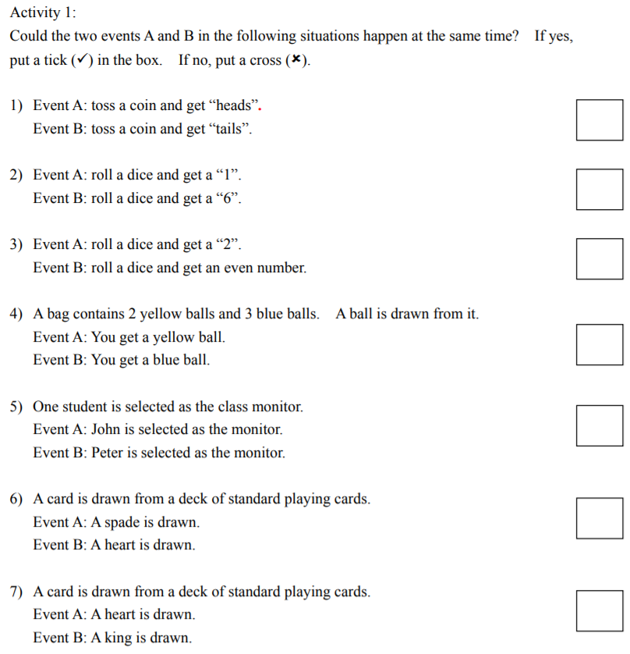

Name: ______________________ Table #:______ Period: ____ Date: _______

**15.5C HW**

**Complementary Event**

**For any event A, P(A) + P(A’) = _______, that is P(A’) = ______- P(A).**

1. Suppose that an event A has probability of . What is P(A’)? ______________

2. Suppose that the probability of snow is 0.58, what is the probability that it will

NOT snow? ________________

**Mutually Exclusive Event**

**If A and B are *mutually exclusive* events, then P(A or B) = P(A) + P(B) – P(AB).**

**Inclusive Event**

**If A and B are *inclusive* events, then P(A or B) = P(A) + P(B) – P(AB).**

There are 52 cards: 26 red and 26 black; 13 ranks: Ace, 1-10, Jack, Queen, and King; 4 suits: hearts, diamonds, spades and clubs (13 hearts/diamonds/spades/clubs); each rank has four cards (one for each of the four suits and two for each color); Jack, Queen, and King are considered face cards (12 face cards in total)

A card is chosen from a well-shuffled deck of 52 cards.

What is the probability that the card will be:

3. a king OR a queen? ______________________

4. a red jack OR a black king? _______________________

5. a face card OR a card with a prime number? ______________________

6. an even card OR a red card? ____________________

7. a spade OR a jack? ________________________

BACK 🡪

A spinner number 1-10 is spun. Each number is equally likely to be spun.

What is the probability of spinning:

8. an even number OR a power of three? ____________________

9. an odd number OR a power of three? ____________________

10. a number less than 8 OR a divisor of 15? _____________________

11. Look at the solution to the following problem and see if you can find the error (there definitely is a mistake). Correct the error to find the right answer.

P(drawing an ace OR a black card) = P(ace) + P(black) =  +  =  = 

++++++++++++++++++++++++++++++++++++++++++++++++++++++++++++++++++++++++++++++++++++++++++++++++

**MULTIPLE CHOICE:**

12. A coin is tossed and a die with numbers 1-6 is rolled. What is P(heads and 3)?

a. 1/12 b. 1/4 c. 1/3 d. 2/3

13. Two cards are selected from a deck of cards numbered 1 – 10. Once a card is selected,

it is not replaced. What is P(two even numbers)?

a. 1/4 b. 2/9 c. 1/2 d. 1

14. Which of the following is NOT an example of independent events?

a. rolling a die and spinning a spinner

b. tossing a coin two times

c. picking two cards from a deck with replacement of first card

d. selecting two marbles one at a time without replacement

15. A club has 25 members, 20 boys and 5 girls. Two members are selected at random to

serve as president and vice president. What is the probability that both will be girls?

a. 1/5 b. 1/25 c. 1/30 d. 1/4

16. One marble is randomly drawn and then replaced from a jar containing two white marbles and one black marble. A second marble is drawn. What is the probability of drawing a white and then a black?

a. 1/3 b. 2/9 c. 3/8 d. 1/6

17. Events A and B are independent. The P(A) = 3/5, and P(not B) = 2/3. What is P(A and B)?

a. 2/5 b. 1/5 c. 4/15 d. 2/15

<https://www.iss.k12.nc.us/cms/lib4/NC01000579/Centricity/Domain/2843/8-4%20exclusive%20inclusive%20CN%20acad%20F15.pdf>

<https://www.edb.gov.hk/attachment/en/edu-system/primary-secondary/applicable-to-secondary/moi/support-and-resources/maths-education-secondary-1-to-3/s3%20topic%203%20probability-mutually%20exclusive%20events.pdf>

<https://static.bigideasmath.com/protected/content/pe/ca/adv2_15.pdf>