Name Date

CHAPTER 5 GROUP TEST

Chapter

5

Write the ratio as a fraction in simplest form.

1. 15 girls to 6 boys 2. 24 players : 3 teams

Find the unit rate.

3. 405 rotations in 5 minutes 4. 72 ounces for 12 servings

Tell whether the ratios form a proportion.

5.  6. 

7. The table shows the rates   
for sending text messages.   
Are the rates proportional?   
Explain.

|  |  |
| --- | --- |
| Messages | Cost |
| 50 | $6 |
| 75 | $9 |
| 100 | $12 |

Use the table to write a proportion.

8. 9.

|  |  |  |
| --- | --- | --- |
|  | Saturday | Sunday |
| Minutes | *m* | 32 |
| Miles | 3 | 4 |

|  |  |  |
| --- | --- | --- |
|  | Serving  A | Serving  B |
| Servings | 2 | 5 |
| Calories | 310 | *c* |

BACK 🡪

10. You can buy 5 stickers for $3. Write a proportion that gives the   
cost *c* if you buy 12 stickers.

Graph the line that passes through the two points. Then find the   
slope of the line.

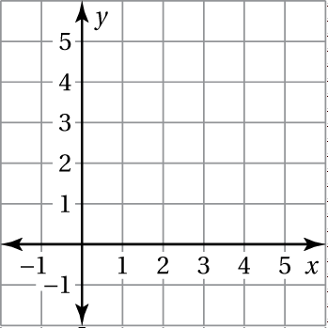 11. 

Slope = m = _______________________

Description of slope: ________________________

12. It costs $145 for 10 people to attend a concert. How much does it cost   
a group of 8 people?

13.  14. 15. 