Name: __________________________ Table #: ______ Period: ______ Date: ______

CH 5 PRACTICE HW

HW: CH 5 Practice Test #1-15, skip #12 (on BIM)

Ch. 5 Practice Test WARM UP
- A line with a positive slope intersects a horizontal line 5 units above the x-axis. Select each point that can NOT be the intersection of the 2 lines.  - (6, 7) B. (5, 4) C. (4, 5)  D. (-3, 5) E. (5, -5)  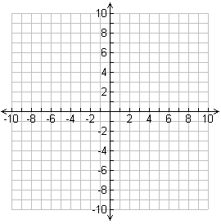 | - A line with a positive slope intersects a vertical line 3 units left the y-axis. Select each point that can NOT be the intersection of the 2 lines.  - (-3, 7) B. (5, -3) C. (3, 5)  D. (-3, 5) E. (5, -3)

WORK SPACE

