Name:__________________________ Table #: ____________ Period: _________ Date: __________
CH 5 Review All Three Methods _HW
Find the solution by graphing
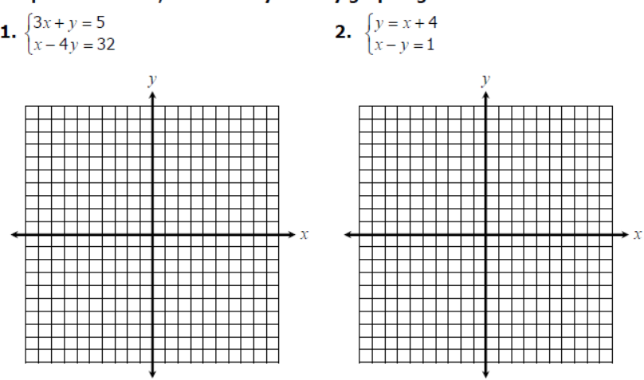

Solution: _____________ Solution: _____________

BACK

Find the solution by using any methods (substitution or elimination method)

Solution: _____________ Solution: _____________

Solution: _____________ Solution: _____________

ANSWERS: 1. (4, -7) 2. No solution 3. (-1, 2) 4. (4, 1) 5. IMS 6. (-3, 5)

