Name: _________________________________________ Table# ___ Period _____ Date _________

CH 7 Review 7.1-7.4 NOTES
HW: CH 7 Review Exercises pg 325_#1-4 ALL, 8-17 ALL
Similar Test Questions to #16: The picture frames shown are both square. The area of the smaller frame is 25 sq inches. The area of the larger frame is 4 times the area of the smaller frame (the area of the smaller frame is ¼ the area of the larger frame). Find the side length of the larger frame.
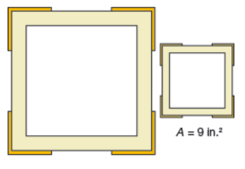 Side length of the larger frame is ________ in.
A = 25 in²

Similar Test Questions to #17: The volume of a cube-shaped shipping container is 4096 cubic centimeters. Find the edge length of the shipping container.

The edge length of the shipping container is ________ cm.
Similar Test Questions to #20: A civil engineer is mapping the overhead clearance of his family’s property on a coordinate grid. The ground is represented by the x-axis and the base of the house is at the origin. There are two big trees on the property. One tree is 8 feet from the base of the house and 13 feet tall. The other tree is 12 feet from the base of the house and is 10 feet tall. What is the distance from the base of the house to the closest treetop? Round your answer to the nearest tenth.

The distance from the base of the house to the closest treetop is ______ ft.

BACK

PRACTICE PROBLEMS
PLEASE CIRCLE ANSWERS. BE SURE TO INCLUDE UNITS OF MEASURE WHERE APPROPRIATE. WORK ON THE FOLLOWING PROBLEMS WITH YOUR PARTNER/TABLE.

- Find the value of x. Round your answer to the nearest hundredth.
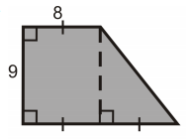
X

- Which of the following expressions are greater than 10 and less than 15? CIRCLE ALL THAT APPLY. Show your work.
i. $\sqrt{101}$ ii. $\sqrt{12}$ iii. $\sqrt{85}$ iv. $\sqrt{200}$ v. $\sqrt{144}$ vi. $\sqrt{15}$

- Which of the following are irrational? CIRCLE ALL THAT APPLY. Show your work.
i. $\sqrt{36}$ ii. $\sqrt{37}$ iii. $\sqrt{25}$ iv. $\sqrt{24}$ v. $\sqrt{3}$ vi. $\sqrt{4}$

- A right triangle has a leg measuring 24 units. Which of these statements is correct? Select two that apply. (Show your work for full credit)
- If the length of the hypotenuse is 25 units, the length of the other leg is 7 units.
- If the length of the hypotenuse is 26 units, the length of the other leg is 12 units.
- If the length of the hypotenuse is 28 units, the length of the other leg is 14 units.
- If the length of the hypotenuse is 30 units, the length of the other leg is 18 units.

