Course 3: CA
Chapter 8 Practice Test
Exercise 1
Find the volume of the cylinder. Round your answer to the nearest tenth.
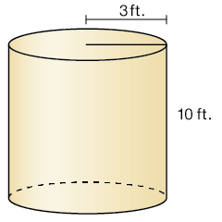
Exercise 2
Find the volume of the cylinder. Round your answer to the nearest tenth.
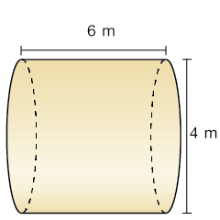
Exercise 3
Find the volume of the cone. Round your answer to the nearest tenth.
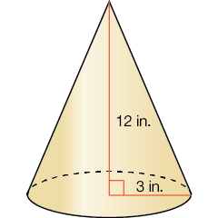

Exercise 4
Find the volume of the cone. Round your answer to the nearest tenth.
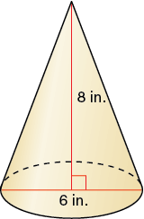

Exercise 5
The volume of the cone is 209.3 cubic inches. Find the diameter. Round your answer to the nearest whole number.
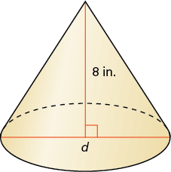
Exercise 6
Find the volume of a sphere with a radius of 6 inches. Round your answer to the nearest tenth.

Exercise 7
Find the radius of a sphere with a volume of 36π cubic inches.

Exercise 8
Select the cone(s) that are similar to a cone with a height of 8 meters and a radius of 6 meters.
cone with a height of 12 meters and a radius of 9 meters
cone with a height of 9 meters and a radius of 5 meters
cone with a height of 4 meters and a radius of 3 meters
cone with a height of 2 meters and a radius of 1 meter

Exercise 9
The solids are similar. Find the missing dimension.
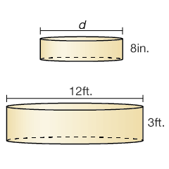
Exercise 10
The spheres are similar. The surface area of the blue sphere is 7854 square inches. What is the surface area of the red sphere? Round your answer to the nearest tenth.
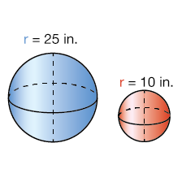

Exercise 11
Water flows at a rate of 6000 cubic inches per minute into a cylindrical tank. The tank has a diameter of 180 inches and a height of 72 inches. What is the height, in inches, of the water in the tank after 5 minutes? Round your answer to the nearest tenth.

Exercise 12
A cylinder and a cone have the same volume. The cylinder has radius x and height y. The cone has radius 2x. Find the height of the cone in terms of y.

Exercise 13
A sphere and a right cylinder have the same radius and volume. The cylinder has a height of 3 inches. Find the radius.

Exercise 14
There are 7 similarly shaped figures in a set. The largest figure is 7 inches tall. Each of the other figures is 1 inch shorter than the next larger figure. The surface area of the largest figure is 588 in². What is the surface area of the smallest figure?

Exercise 15
A bale of hay in the shape of a rectangular prism has a length of 4 feet, a width of 2 feet, and a height of 2 feet. A cylindrical bale of hay has a diameter of 5 feet and a height of 6 feet. How many rectangular bales contain the same amount of hay as one cylindrical bale? Round your answer to the nearest tenth.

Exercise 16
A cylindrical swimming pool has a diameter of 16 feet and a height of 3 feet. How many gallons of water can the pool contain? Round your answer to the nearest whole number. (1 ft³ ≈ 7.5 gal)

Exercise 17
You have 8 gallons of lemonade to sell. You use cone-shaped cups that are 9 centimeters in diameter and 12 centimeters tall. Each customer uses one paper cup. How many paper cups will you need if you sell all of the lemonade? (1 gal ≈ 3785 cm³)

Exercise 18
A spherical ball with a volume of 972π in.³ is packaged in a box that is in the shape of a cube. The edge length of the box is equal to the diameter of the ball. What is the volume of the box?

Exercise 19
A cylindrical container of four rubber balls has a height of 20 centimeters and a diameter of 5 centimeters. Each ball in the container has a radius of 2.5 centimeters. Find the amount of space in the container that is not occupied by rubber balls. Round your answer to the nearest whole number.
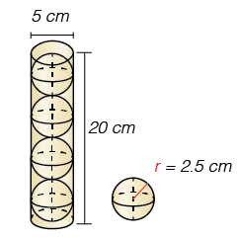
Exercise 20
The ratio of the corresponding linear measures of two similar cans of vegetables is 5 to 8. The smaller can has a surface area of 300 square centimeters. Find the surface area of the larger can.

